Texas Windstorm Insurance Association
Texas FAIR Plan Association

Property Damage Evaluation Guidelines
Table of Contents
Table of Newer Revisions 7
Purpose of Document 8
Introduction 8
Disclaimer 8
Resource Management System (RMS) 9
www.twia.org/adjusters General Field Adjuster Guidelines 9
Role & Responsibilities: 9
Expectations 10
Field Adjuster Timeline Expectations 10
Claims Examiner Timeline Expectations 11
Initial Claim Review 11
TWIA Endorsements 11
TWIA - Food Spoilage, ALE and Wind Driven Rain Coverage Table 12
TWIA – First Notice of Loss 13
TFPA First Notice of Loss. 15
Initial Contact 16
Temporary Repairs, Emergency Repairs, or Additional Living Expenses (ALE) 16
Tree Removal: 17
Policy Limits Handling Guidelines 17
Status, Initial, and Final Reports 18
Status Reports 18
Initial / Final Reports 19
General Loss Report (GLR) 19
Photos 20
Diagramming and Measurements 20
Interior Diagrams 21
Inspection 22
Mortgagee 22
Denials 22
Contact/Inform TWIA & TFPA 23
Adjuster Leave-Behind and other TWIA provided communications 23
General Roof Loss Guidelines 23
Shingle Gauges 23
Brittleness Test 24
Roof Inspector Safety: 24
Hail Damage to Asphalt Shingle Roofs 24
Evaluation of hail damaged roofs: 24
Wind Damaged Roofs 25
Unsealed Shingles 25
Storm Created Openings & Wind Driven Rain 26
Siding/Paint/Stucco These claims should be evaluated on the basis of each individual elevation: 26
Pools 26
Filling 26
Pool Decking 27
Fences 27
Shared/Common Fences 27
Sheds, Outbuildings, and Other Structures 28
Pricing for sheds, other outbuildings, and other structures: 28
Retaining Walls 28
Breakaway Walls 28
Metal Screen Enclosures 29
Interior Damages 30
Remediation 30
Water 30
Mold 30
Asbestos 30
Natural Breaks 31
Drywall 31
Plaster 31
Wall Coverings 31
Paint 31
Wall and Ceiling Texture 32
Wallpaper 32
Flooring 32
Carpet 32
Wood Floors 33
Tile Floors 34
Vinyl Floors 34
Multiple Layers of Floor Coverings 34
ITEL 34
Electrical 35
Water Damage to Electrical Fixtures 35
Insurable Interest 35
HVAC 35
Repairability Reports 35
Repairability 35
Ductwork 35
Mobile/Manufactured Homes 35
Wind Driven Rain 36
Re-leveling 36
Interior 37
Xactimate Grades for Mobile Homes 37
Condo Handling Guidelines 37
Personal Property 37
Field Adjuster Expectations for Personal Property Handling 38
Theft, Vandalism & Malicious Mischief, and Lightning 38
Identification of Building items versus Personal Property 39
Estimating 40
Like Kind and Quality 41
General Estimate Guidelines 41
Insured Completed Labor Hours/Repairs 41
Roof Estimate Guidelines 42
Roof Waste Factors 43
Additional Roof Loss Evaluation Considerations: 44
Overhead and Profit 44
Depreciation 45
Items Subject to Depreciation 45
Guidelines on Withholding of Recoverable Depreciation 45
Guidelines for use of Non-Recoverable Depreciation 45
Permits 45
Sales Tax 46
Salvage 46
Subrogation 46
Contractors/Public Adjusters 47
Contractor Estimates 47
Hiring a Contractor 47
Public Adjusters 47
Supplemental Payments and Supplemental Claims 47
Appraisal Requests and Letters of Representation 48
XactAnalysis How-to 48
Add a document 48
Request EagleView Roofing Measurement Report 50
QA Approve 51
XactAnalysis Assignment Workflow 51
QA Approval: 52
Commercial Property Damage Evaluation Guidelines 53
Roles and Responsibilities 53
Claims Manager 53
Claims Examiner 53
Independent Field Adjusters 53
Professional Engineer (PE) 54
Building Consultants (BC) 54
Independent Contractors (IC) 55
Authority of the Policyholder’s Representative 55
Commercial Policies Insured by TWIA 55
Governmental Entities 55
Essential Services 56
Condominiums, Townhouses, and Apartment Buildings 56
Churches and Historical Buildings 57
Large Commercial 57
Small Commercial 57
Investigation and Reporting 57
Reserve Recommendations 57
Core Samples 58
Roof-Top Mounted Equipment 59
Aerial Images 59
Claims with a Large Number of Insured Items 59
Uploading Large Reports 60
Emergency Services 60
Evaluating the Loss 60
Other loss evaluation guidelines: 61
Material and Labor Sales Tax on Repair Estimates 61
Commercial HB-3 Policy 63
Coverage A 63
Coverage B 64
Common Endorsements 65
Endorsement 164 – Replacement Cost Endorsement 65
Endorsement 282 (1) or (2) – Condominium Property Form 66
Endorsement 17 – Business Income Form 66
Endorsement 432 – Increased Cost of Construction 67
Endorsement 26 – Church Form 67
Endorsement 176 – School Form 67
Endorsement 18 -- Builder’s Risk Stated Value Form 67
Endorsement 21 -- Builder’s Risk Actual Completed Value Form 67
Table of Older Revisions 69

Table of Newer Revisions

Revision Date | Page # | Revised Section | Comments
5/23/19 | ALL | ALL | Removed absolute language such as “will”, “always”, “never” from document
5/23/19 | ALL | ALL | Change use of Eagleview to generic “aerial imagery provider” as provider may change in the future.
5/23/19 |  | Drywall | Remove drywall size requirements
5/23/19 |  | Wall Coverings – Paint | Updated so that new drywall is sealed and painted with two coats of paint versus one coat.
5/23/19 | Page 35 -37 | Natural Breaks & Floor Coverings | Remove doorways from what is considered a natural break.
5/23/19 | Page 38 | Tile Floors | Update section to account for modern construction methods and use of thinset as well as a mortar bed.
5/23/19 | Page 38 | Tile Floors | Removed line stating, “tile by its very nature does not stain.”
5/23/19 | Page 40 | Mobile Home Coverage | Remove section entirely as TFPA does cover mobile/manufactured homes.
5/23/19 | Page 44 | Building vs Personal Property | Updated names for a/c units specifically identifying what types are building vs personal property.
5/23/19 | Page 46 | Roof Estimate Guidelines | Addition for satellite dishes and antennas not being covered under TWIA Policy.
5/23/19 |  | Photo Requirements | Addition of how gutters are hung photo
5/23/19 | Page 47 | Waste Factors | Amended section to outline new guidelines using Xactimate’s Roof Waste Tool
5/23/19 | Page 18 | TFPA Policy Table Guide | Updated TFPA Policy names as well as effective date
5/23/19 | Page 11 | Disclaimer | Included in the event of a catastrophe
5/23/19 | Page 22 | Status Reports | Amended section to include Activity Report and image showing how to add a status note in XactAnalysis
5/23/19 | Page 32 | Breakaway Walls | Updated section to include sill/bottom plate connection photo. Example is provided
5/23/19 | Page 20 | Temporary or Emergency Services | Updated title of section to include ALE
5/23/19 | Page 20 | Temporary or Emergency Services | Added field adjuster documentation regarding length of repairs
5/23/19 | Page 21 | Temporary or Emergency Services | Updated pre-loss prevention paragraph to include coverage for Property Removed.
5/23/19 | Page 43 | Permits | Revised handling on permits
8/12/19 | Multiple Places | Removed ITV/MSB requirements | In light of legislative changes, removed requirement to calculate ITV at point of claim

TWIA & TFPA Damage Evaluation Guidelines

Purpose of Document
The guidelines contained in this document were prepared by the Texas Windstorm Insurance Association (TWIA) and the Texas FAIR Plan Association (TFPA) for use by their staff, their contracted independent field adjusting firms and their adjusters, as well as other business partners involved in the evaluation, handling, and servicing of TWIA’s & TFPA’s claims.
Guidelines described in this document may differ for individual claims depending upon the unique facts and circumstances of each individual claim. This document is intended to serve as a guideline only - the adjuster should apply professional discretion as each claim is unique.
These guidelines were composed to comply with applicable insurance policies, contracts, and the laws, rules and regulations of the State of Texas. In the event of any conflict, applicable laws and regulations will prevail.

Introduction
TWIA & TFPA expect high levels of customer service, communication, professionalism, and expertise at all times. In addition, a strong sense of urgency and an appreciation of the importance of uniform compliance with policies, laws and regulations from all our employees and business partners are expected during the claim process as we assign, dispatch, investigate, evaluate, and pay claims.

Disclaimer
This is a living document and thus, it is subject to revision. It is prepared as an aid to staff, contractors and associated firms and cannot be relied upon by the regulated community as representation of the law. Any policy and/or endorsement excerpts, examples, or selections represented in this document may not reflect the official version. In the event of inconsistency or discrepancy, the controlling policy, regulation or law prevails. This document may be revised, as necessary, to reflect any relevant future amendments. In addition, guidelines provided in this document may be amended in the event of a catastrophe. During catastrophe events, unique circumstances arise and updates to the Property Damage Evaluation Guidelines may be necessary. If this is the case, amended guidelines will be distributed to the necessary parties.
Printed or distributed copies cannot be controlled. Announcements contained in such printed or electronic material are subject to change without notice and may not be regarded in the nature of binding obligations on the Associations and/or the State.

Resource Management System (RMS)
TWIA & TFPA have implemented a new Resource Management System (RMS). The RMS platform is hosted through Adobe Captivate Prime and is used to provide a broad range of training courses and certification functions for TWIA and TFPA.
In addition to annual certifications and training materials, the RMS will provide you access to resources including but not limited to:
- Fee Schedules
- Property Damage Evaluation Guidelines (PDEG)
- Storm-specific guidelines
- Direct communication from TWIA/TFPA
To get registered on the RMS, please contact your firm who will provide you with their specific registration link.
For further information regarding certifications and requirements, please click on the following link.

www.twia.org/adjusters
General Field Adjuster Guidelines

Role & Responsibilities:

Field Adjuster
The Field Adjuster’s responsibility is to inspect and document all damaged insured property, and to submit that report to the Claims Examiner. This requires detailed conversation with the insured, on-site inspection of the property, access to all parts of the property, and enough time to diligently conduct all components of the inspection.
The Field Adjuster also serves as the most visible customer-facing part of TWIA/TFPA. They should always show empathy and patience as they help the insured navigate the early portions of the claims process.
The Field Adjuster is not responsible for determining coverage underneath the TWIA/TFPA policy and therefore should not explain what is covered and what is not covered unless under specific direction to do so by the inside examiner at TWIA/TFPA. Likewise, the Field Adjuster cannot make any commitments in terms of payments to the insured.
Conversation with the insured should always be conducted with a high level of professionalism. This means that the field adjuster should not discuss the following:
- Their experience level as a field adjuster
- Claim/file load
- How many claims they have inspected or have left to inspect
- Other carriers they have worked for and how other carriers handle claims
In addition, all opinions about whether or not a loss could exceed policy limits, should not be discussed with the insured. This decision, as all coverage decisions, are the responsibility of the claims examiner.

Claims Examiner
The Claims Examiner’s responsibility is to review the information submitted by the Field Adjuster and apply the policy terms and conditions to that inspection report. They are also responsible for then communicating that determination to the insured, both verbally and in in the form of a detailed letter, as well as communicating the benefits available under the policy.

Expectations
Below is a brief list of common timeline expectations, both for the Field Adjuster and the Claims Examiner. Every claim is unique and should be handled on its own merits. As a result, any specific claim may deviate from the below timeline. However, any deviation from the below expectations should be documented and explained by the Field Adjuster.
Claims Examiner expectations are included to help the Field Adjuster set appropriate expectations with the insured. Like above, however, actual timeframes may deviate depending on the unique and individual circumstances of that specific claim. Field Adjusters should set expectations but always caution the insured that each claim is unique and is handled on its own merits, so the actual timeline of their claim may vary.

Field Adjuster Timeline Expectations
From Assignment to Voice-to-Voice Contact | 24 Hours | These Timeline Expectations are subject to change in the event of a Catastrophe | Total Time – 7 Days from Assignment to QA Approval of Estimate & Report
From Voice-to-Voice Contact to Inspection | 48 Hours
From Inspection to return of Field Adjuster Estimate & Report | 72 Hours  If the claim is a Large Loss, the adjuster should submit an initial report in 24 hours and ask the Claims Examiner how they should proceed | These Timeline Expectations will not change, even in the event of a Catastrophe
From return of Field Adjuster Estimate & Report to QA Approval in Xactanalysis by the firm | 24 Hours
Response to revision request | 48 Hours

Claims Examiner Timeline Expectations
From Receipt of Field Adjuster Estimate & Report to Review & issuing of payment/letter | 5 business days (7 calendar days) | This Timeline Expectation is subject to change in the event of a Catastrophe | Total Time – 14-17 calendar days from submission of Field Adjuster Estimate & Report to policyholder receipt of payment/letter
From Review & issuing of payment/letter to insured Receipt of payment/letter | 7-10 calendar days (any check will arrive separately from the letter) | This Timeline Expectation will not change, even in the event of a Catastrophe

Initial Claim Review
Upon receipt of a new claim, it is important that the Field Adjuster thoroughly review the first notice of loss and applicable policy endorsements. Below is additional information regarding both TWIA and TFPA policies and endorsements along with an example of a TWIA First Notice of Loss.

TWIA Endorsements

310 Endorsement – Extensions of Coverage
Provides coverage for consequential loss and food spoilage – please see Table below for further details

320 Endorsement – Extensions of Coverage
Provides coverage for consequential loss, ALE and wind driven rain – please see Table below for further details

330 Endorsement – Extensions of Coverage
Provides coverage for consequential loss ONLY – please see Table below for further details

365 Endorsement – Replacement Cost Coverage
Provides replacement cost coverage to your personal property along with carpet and cloth awnings. For personal property, we will pay the replacement cost coverage up to $1,500 and ACV for the remaining personal property. Insured’s have 545 days from date of payment to recover replacement cost benefits.

400 Endorsement – Actual Cash Value Roofs
Payment for covered losses to roof coverings will not exceed the actual cash value of the damaged property. Roof coverings include the roofing material, underlayment (felt), and all flashings.

411 Endorsement – Conversion to TWIA Manufactured Home Policy
Converts the dwelling policy to a Manufactured Home Policy. This is an ACV policy that provides coverage for the dwelling and personal property. Please see further information about the Mobile/Manufactured Home Policy here.

431 Endorsement – Increased Cost of Construction
Provides coverage for the increased costs that are incurred due to the enforcement of any ordinance or law.

TWIA - Food Spoilage, ALE and Wind Driven Rain Coverage Table

 | 310 | 320 | 330
Consequential Loss – On Premise * | Covered – Policy Limit, no deductible applies | Covered – Policy Limit, no deductible applies | Covered – Policy Limit, Coverage B deductible applies
Consequential Loss – Off Premise * | Covered - $500 Limit | Covered - $500 Limit | No Coverage
ALE | Covered | Covered | No Coverage
Wind Driven Rain | No Coverage | Covered | No Coverage

Consequential Loss is often referred to as food spoilage, however, the policy defines it as:
- On Premise - any damage that is due to change in temperature as a direct result of physical damage to the dwelling or any equipment contained in the dwelling, caused by windstorm or hail.
- Off Premise – any damage due to changes in temperature as a direct result of physical damage to any power, heating or cooling equipment (including connections and supply pipes) not contained in or on the dwelling, caused by windstorm or hail.
Examples:
If the food spoilage inside the refrigerator causes the refrigerator to smell and to be considered unrepairable, then the replacement of the refrigerator would be considered a part of the consequential loss as well as the food spoilage.
If the refrigerator leaks due to a power outage and causes water damage to the floor underneath, this would be considered a part of the consequential loss as well.
In both examples, be mindful of any applicable limits ($500) that may apply.

TWIA – First Notice of Loss
Below is key information that the field adjuster should obtain when reviewing a first notice of loss for TWIA.
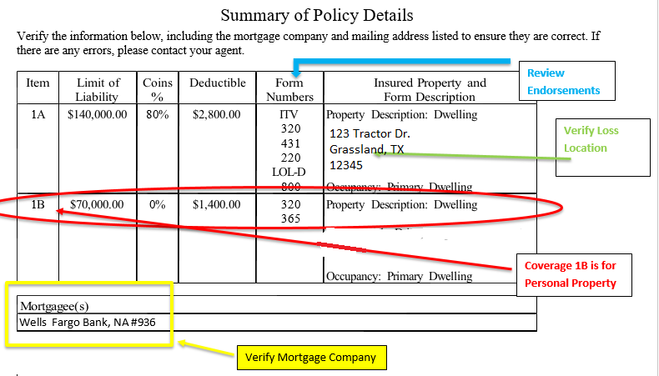
TFPA Policy Table Guide
Below is a quick reference guide intended to assist the field adjuster with coverage afforded under TFPA policies and popular endorsements. By no means is this a complete guide to all endorsements and coverages provided under TFPA. A field adjuster should review the entire policy and/or endorsements for applicable coverages.
 | Homeowners* | Dwelling* | Condominium* |  | Tenant *
Exposures | Dwelling, Personal Property | Dwelling, Personal Property | Personal Property | Personal Property
Other Structures | 10% of Coverage A Limit or as shown on Declarations | 10% of Coverage A Limit or as shown on Declarations | N/A | N/A
Additions & Alterations | N/A | N/A | Provides coverage for alterations, fixtures, installations and additions | Improvements, alterations and additions are covered at 10% of Coverage B
Coverage | ACV  RCV available with endorsements | ACV – no exceptions | ACV  RCV available with endorsements | ACV  RCV available with endorsements
Perils Insured Against | All 8 Named Perils | 7/8 Named Perils – Excludes Theft * | All 8 Named Perils | All 8 Named Perils
Sudden & Accidental Water Damage | Available with HO-400 Endorsement  ($5,000/policy period limit) | No Coverage | Available with HO-401 Endorsement  ($5,000/policy period limit) | Available with HO-401 Endorsement  ($5,000/policy period limit)
ALE | Included | No Coverage | Included | Included
Excludes  Wind, Hail and Hurricane | HO-140 | TDP-001 | HO-806 | HO-806B
Provides RCV for Dwelling | HO-802 | N/A | N/A | N/A
Provides RCV for Personal Property | HO-803 | N/A | HO-803 | HO-803
Mold, fungi, or other microbes and the treatment of asbestos are not covered under any of the policy forms

* The TFPA Homeowners, Dwelling & Condominium policies were changed effective November 28, 2016.
* The TFPA Tenant Policy was changed effective February 1, 2017
On TDP-1/Dwelling policies review the policy declarations page and the first notice of loss to identify what perils insured against are included on the policy. Below are the acronyms used to identify the covered perils on a policy.
- Fire = fire
- EC = extended coverage (provides coverage for lightning, smoke, wind/hail, explosion, aircraft or vehicle, riot and civil commotion
- VMM = vandalism and malicious mischief

TFPA First Notice of Loss.
Below is a sample first notice of loss for TFPA. The field adjuster should adequately review the first notice of loss to familiarize themselves with the loss location, the covered perils and the associated endorsements attached to this policy.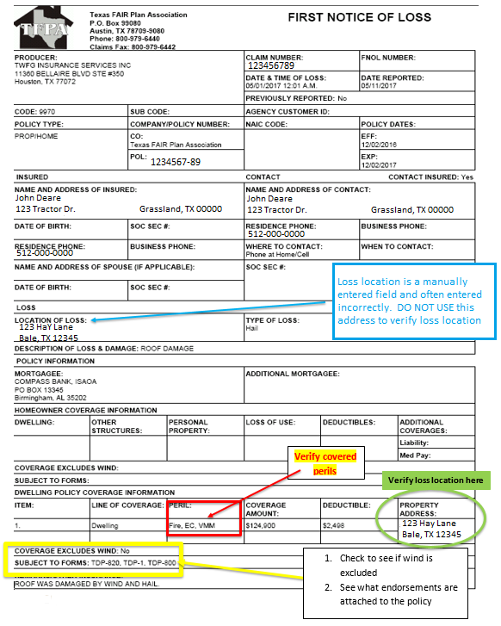

Initial Contact:
Initial Contact is expected on the same day as, or less than 24 hours from assignment
Initial contact is direct voice to voice contact. Text message and automated programs are not acceptable alternatives. On direct voice-to-voice contact the Field Adjuster should clearly identify who they are contacting on behalf of (Texas Windstorm or Texas FAIR Plan) and why (the claim they filed for x-property on y-date).
It’s important that the Field Adjuster express empathy and concern for the insured during the initial contact and throughout the entire claim.
Below are some key items that should be discussed during your initial contact:
- Verify loss location and contact information
- Obtain a brief overview of damage inquiring about the following
  - Is the insured safe? Is their home secure? Do they have somewhere to stay?
  - Other structures/fence
  - Interior damage
  - Contents
  - Roof Information for access purposes
  - Need for temporary repairs – see below
  - Tree Removal – see below
Information obtained in the initial contact should allow the Field Adjuster to appropriately triage the assignment and determine how much time may be required to complete a thorough inspection. Be sure that when scheduling your appointments that you allow adequate time to properly inspect the entire property.

Temporary Repairs, Emergency Repairs, or Additional Living Expenses (ALE)
The need for emergency services, mitigation, and other temporary repairs should be addressed both at the time of initial contact and during the inspection. This is both to protect the property from further loss as well as provide the insured with needed peace of mind. A loss has been suffered so direction and empathy should be demonstrated by the Field Adjuster to reassure and help the insured. Field Adjusters should ask the insured on first contact:
- Can the property and its contents be secured?
- Is there a tree on covered property that needs to be removed?
- Does the property still have full access to utilities, specifically electricity and water?
- Is there water damage inside the property which needs to be mitigated to prevent further damage?
- Are other temporary repairs or mitigation needed to further protect the property (such as board-up of windows, tarp on roof, etc.)?
Special attention should be paid to whether the insured is able to still inhabit the home or whether there is a need for advanced payment and/or ALE. The field adjuster should confirm with the policyholder if they are seeking additional living expenses and whether the property is a primary or secondary residence. In such cases where ALE or emergency services are needed, communication with the Claims Examiner should happen immediately so that emergency services, board-up, ALE, and anything else the property owner requires can be secured. A recommendation for an advanced payment should be provided as well as any reserve recommendations. In addition, the field adjuster should document how long the
estimate repairs will take. This information should be fully documented in the adjuster’s General Loss Report as well. The Field Adjuster should not discuss or commit to any coverage concerning ALE or temporary services as this should be handled by the Claims Examiner. The Field Adjuster’s responsibility is only to gather information and report it back to the Claims Examiner.
Explain that permanent repairs should not be made before the property is inspected so the Field Adjuster can document the damage and provide TWIA or TFPA with enough information to determine if it was caused by a covered peril. Ask the insured to provide accurate records, receipts, pre-repair photos, or other documentation for any temporary repairs.
Field Adjusters should estimate for any temporary repairs or mitigation needed in the case of storm created openings to prevent further additional damage, regardless of whether the repairs have been completed at the time of inspection.
Most pre-loss prevention measures taken by an insured are not covered under the TWIA/TFPA policy. An example of this would be costs associated with the temporary board up of windows in preparation of a hurricane. In addition, any damage that is a result of pre-loss prevention measures is not covered. For example if an insured boards up their windows prior to a hurricane making landfall, any damage from nail holes to the window trim is not considered covered damage.
However, property removal from the described location endangered by windstorm or hail (see Extensions of Coverage – Property Removed) along with any measures taken by an insured to protect their property after damage has occurred is covered under the policy. For instance, if a windstorm causes a tree to fall on the insured’s home and the insured needs to tarp the roof to prevent further interior water damages, this would be covered under the policy.

Tree Removal:
Tree Removal is covered under Extensions of Coverage under TWIA/TFPA policies. Extensions of coverage are not additional insurance and do not increase the limit of liability. If a covered peril has caused a tree to fall and damage covered property, we will pay for the expense for the removal from the described location. If the tree needs to be removed to mitigate any further damages before the Field Adjuster is able to perform the inspection, ask the insured to take pictures and keep receipts.
If the tree has not yet been removed at time of inspection, as much of the property should be safely inspected as possible and a preliminary inspection report and estimate prepared. Estimate for the removal of the tree and notify the Claims Examiner of the need for tree removal and possible advanced payment for mitigation of further damage.
If additional questions or concerns arise, please consult the TWIA/TFPA Claims Examiner assigned to the loss.

Policy Limits Handling Guidelines
It is possible that you may arrive to a site where the loss could exceed the policy limits. If this happens, the Field Adjuster will need to follow the guidelines listed below:
- Take adequate photos to document the damages. A photo of each elevation is not sufficient, and your report may not be accepted.
- While on-site, attempt to contact the claims examiner to notify them that the claim is likely to exceed policy limits.
- Write up an initial report to provide to the Claims Examiner within 24 hours of inspection. At that time, an estimate should not be prepared, but reserve recommendations should be made via Xactimate/XactAnalysis.
- Show the insured empathy, make sure they have somewhere to stay. If temporary accommodations and/or an advance is needed, contact TWIA/TFPA immediately so that the process can begin for the insured.
Once your initial report and photos are submitted, Texas Windstorm and Texas FAIR Plan will review the information and make a decision about the next steps. The claims examiner will determine and advise the field adjuster if:
- Policy limits may be warranted and paid
- Field Adjuster may be asked to write an estimate of repairs
- Building Consultant may be assigned to write an estimate of repairs.
Under no circumstances however, should the Field Adjuster discuss or commit to any coverage for payment authorization. Once again, the Field Adjuster’s responsibility is to inspect and document all damaged insured property, and to submit that report to the Claims Examiner.

Status, Initial, and Final Reports

Status Reports
When there is difficulty in contacting or scheduling with an insured, provide a status report in the form of a note submitted in XactAnalysis and email it to the TWIA/TFPA Claims Examiner every 7 days from the claim assignment until the loss is resolved. Claims Examiners are expected to return any contact from the Field Adjuster within 24 hours, if requested. Do not upload a $0 estimate to XactAnalysis. In addition, the activity report should not be uploaded/approved until the full report is completed.
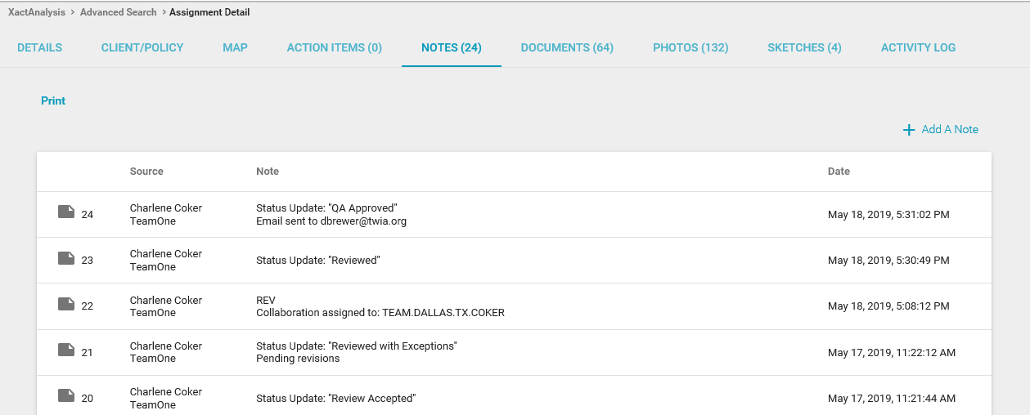

Initial / Final Reports
THERE SHOULD BE NO EXCEPTIONS TO THIS COMPLIANCE TIMELINE
Initial or Final Reports are expected to be provided within 72 hours of the inspection. Even in the event of a catastrophe, an initial or final report should be provided within 72 hours of inspection.

File Documentation
File activity notes should be maintained on all TWIA/TFPA claim files. Activities should be documented in the Field Adjuster’s file or log from first receipt of the assignment to final report submission. Any documentation or evidence the Field Adjuster obtains related to the claim should be evaluated, responded to, included in their file, and provided to TWIA/TFPA.
To Be Included in the Field Adjuster Report (PDFs):
- One copy of your invoice
- Activity Log (including T&E log)
- Field Adjuster’s General Loss Report – see sample
- Loss Recap
- Building/Personal Property Worksheet (estimate/inventory)
- Field Adjuster’s Photo Sheets (labeled) – see sample
- Documents received from insured, including e-mails, estimates, invoices, receipts, photos, Proof of Loss (TFPA claims only), Advance Pay Requests
- Copies of letters/e-mails sent to insured
All documents generated out of Xactimate should use the default naming convention set by Xactimate.
If any documents are not uploaded or not properly filled out, the file may be returned for completion

General Loss Report (GLR)
- Field Adjusters should not copy/paste information into the General Loss Report as it should be filled out according to each individual inspection
- Include any damage identified during the inspection that is not consistent with a named peril.
- After identifying the damage to the roof, make sure to summarize your repair recommendations, specifically identifying if roof is repairable or if replacement is warranted.
Example: Roof
Age/Material/Layers/Reparability/Decking: 3-tab 25yr shingles
Front slope: scattered wind damage
Right slope: scattered wind damage
Left slope: scattered wind damage
Rear slope: scattered wind damage
Soft metals and other roof elements: included in our estimate per TWIA guidelines
We estimated for full roof replacement as there were a number of shingles missing, torn, creased, about 75 total on the roof.

- If there is interior wind driven rain, please confirm the causation for coverage. Whether it is identifying the storm created opening or confirming that the 320 endorsement is present, it should be documented in the GLR.

Photos
Clear digital photos are required. Photos should be numbered, identified by the building or item number and room/area, and include a description. In addition, photos should be labeled with the date the photo was taken. If using photos from a 3rd party source such as EagleView, be sure that when copying and pasting the images into the photo report that the source information (EagleView, other source) and the date taken are included on description for the photo.
Enough photographs should be taken to adequately document the damaged area as well as the undamaged portions of the item.
Each photo should be labeled with its own description. Avoid copying/pasting the same description to multiple photos.

Photo descriptions should be factual, free from speculation or opinion, and sufficiently descriptive to allow the Claims Examiner to identify what is being depicted in the photo and where on the property the photo was taken.

Submit the following photos on all losses:
- Risk overview and badge photo
- Photos showing evidence of single or multiple layers of roofing
- Photo showing how the gutters are hung
- Pitch gauge photo
- Overview of all slopes and test squares
- Close-up photos of most severely damaged shingle(s)
- Photos demonstrating damage or lack thereof to soft metals, screens, gutters, etc.
- Elevation photos - north, south, east, west elevations of the risk
- Overview of all interior rooms and a close-up photo of damaged areas
- Interior attic showing type of roof decking
- Interior attic showing any evidence of interior damage or ongoing leaks
  - NOTE: a photo of the HVAC system condensation pan (drip pan) is needed when interior water damage is reported/claimed near the condensation pan.
- Personal Property when applicable
- Roofs of other nearby structures to document damage or no damage
The Estimate should be written in the same order that the photos are taken above, starting with the exterior.

Diagramming and Measurements
- Diagrams with measurements are required on all field adjusted losses.
- The computer-generated diagram and measurements for any damaged room or area must be uploaded with the Xactimate estimate.
- Measurements should be rounded up to the nearest inch.
- Note the correlation of any interior damage on the diagram or sketch to the exterior damage.
  - Example:
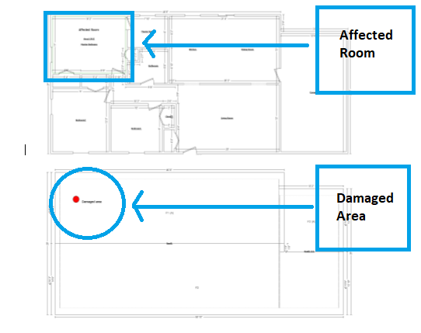

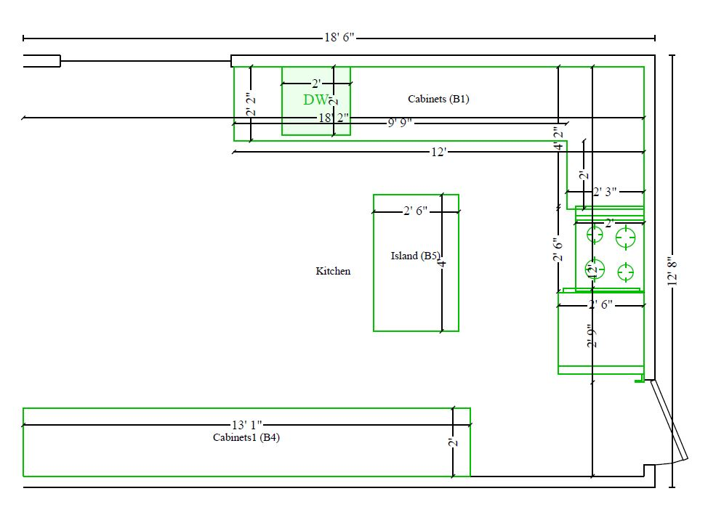
Interior Diagrams
- The diagrams should include the room measurements, ceiling heights, any relevant offsets, and any cabinets or built-ins.
- Kitchen and bathrooms require detailed diagrams of appliance, fixtures, and cabinets.
- Wall openings larger than 50% of the area should be deducted when estimating the replacement of wall finishes or surfaces.
- The diagram with measurements should be completed for the damaged area(s) and any area where the same damaged product was installed to continuous surfaces such as floors, carpeting, wallpaper or siding.
- If the building or dwelling has multiple stories and a thorough inspection reveals the damage is confined to one story (or level), then only the damaged story would require full measurements and a diagram.

Inspection
Inspection is expected to take place within 48 hours of Initial Contact. To ensure all damages are addressed during the initial inspection, the property should be inspected with the Insured or Insured’s representative present. If the Insured is unable to be present within that time frame, put a comment in your file notes explaining the reasons why you were unable to inspect within the desired time frame.
Please be mindful that insureds are often taking time out of their day or time off work to be present and to provide access to their property. If running late or unable to make the inspection, please contact the insured as soon as possible and set proper expectations. No-shows are unacceptable.
Your dress should meet business casual standards and be professional and practical. Denim pants are not permitted. Wear shoes that provide adequate traction for traversing a multi-pitched roof.
Properly greet and introduce yourself to the insured or their representative. Be sure to display patience and empathy. Remember that for many insureds, this is one of the most significant events they’ll go through. Include an explanation of why you are there and what they can expect from your visit and inspection. Present your ID card to confirm your identity and relationship with TWIA/TFPA.
Take your time and walk the entire property with them. Allow them to point out all claimed damages. Point out any damages you observe that the customer does not and confirm whether they intend to make the damage part of their claim. Document and address contents during your inspection if there is potential contents loss. Assess possible need for mitigation or temporary repairs during the inspection.
Even if no interior damage is reported, the interior and attic are required to be inspected. If access is not granted or if the attic is inaccessible, this should be documented in your General Loss Report with a clear explanation on why the attic was not inspected. If an insured, declines an interior inspection, please have them sign the “declination of interior inspection document” and include that in your file submission.
Close your inspection by sharing the next steps of the claims-handling process. Do not discuss what damages are covered or not covered or make any repair recommendations. Simply advise the insured that the damages reported and inspected should be submitted to the Claims Examiner for further handling. End the inspection by asking the customer if there is anything else they would like to present and if your inspection has lived up to their expectations.

Mortgagee
While on-site verify the mortgagee with the insured. If there have been any recent changes, please advise the insured to contact their agent who will need to update the policy with the correct mortgage company.

Denials
If an inspection reveals no covered damage or no damage, do not discuss this with the insured. It is not the responsibility of the Field Adjuster to explain to the insured what is not covered. If the insured asks about the coverage of a particular item, the adjuster should document what is being claimed, clearly and thoroughly, and explain they’ll be sending it to TWIA for their review. Report your findings to the Claims Examiner who will review the policy and make the proper coverage determination.

Contact/Inform TWIA & TFPA
During the inspection if you encounter a claim with any of the following needs, please contact and inform TWIA / TFPA immediately.
- A need for ALE
- Extensive personal property damage
- Reserves are over $50,000
- A potential full denial
- A need to utilize experts

Adjuster Leave-Behind and other TWIA provided communications
TWIA & TFPA may provide documents, brochures, and other communications for you to provide the insured at the time of inspection. TWIA/TFPA requires that you provide and review them with the insured in person whenever possible. These documents will be TWIA or TFPA specific so be sure to verify using the correct document on the correct claim. Example: We are currently providing the firms with a TWIA specific Adjuster Leave-Behind to be given to the policyholder on every residential TWIA claim. Make sure to read through the document with the insured and address any questions they have about the document. Your General Loss Report should indicate what you provided the insured and your conversation with them reviewing it.

General Roof Loss Guidelines
- Roof visual inspections are required on all field-adjusted roof claims.
- TWIA & TFPA use aerial imagery and “CAD” diagrams to establish roof measurements as needed for diagrams.
- When using aerial imagery, the adjuster should verify 3-dimensional measurements (a ridge measurement and slope measurement should normally suffice), and photo document those measurements to confirm the aerial imagery report is accurate.
- When aerial imagery is not available, measurements need to be taken or verified manually and sketched in Xactimate.
- The Field Adjuster report should include the type(s) of roofing, age of roof, slope pitch, and the number of layers of roofing.

Shingle Gauges
Shingle gauges should not be relied upon to determine the kind, quality and age of the shingle material and should no longer be used.
Consequently, Field Adjusters do not need to photograph a shingle gauge measurement of the shingle. Field Adjusters should make sure to discuss the roof age and material with the insured, and specifically ask if the insured has left over materials, receipts, warranty information, or other supporting documentation that can establish the age and type of material.
If questions or a dispute arises about the type of shingle on a property, Field Adjusters should use an expert service for material identification such as ITEL to determine the exact type of shingle and its availability. These claims should be coordinated through the Claims Examiner.
ITEL expenses should be billed as an expense, even if the adjuster otherwise bills according to the Gross Loss Fee Schedule. Do not instruct ITEL to bill TWIA/TFPA separately, all invoices should be paid by the Field Adjuster.

Brittleness Test
- A “brittleness test” should not be conducted to determine the reparability of a roof. To determine if a roof can be repaired the Field Adjuster should review the following items:
  - Age
  - Condition of shingle - conduct a visual inspection to determine the appearance of brittleness, amount of granule loss, cracking and overall deterioration to the roof.
  - Type and extent of damage – wind vs hail and if the damage is isolated or widespread
  - Check to see if there are any previous repairs/patches on the roof that indicate that the roof can be repaired.
- Under no circumstances should the Field Adjuster engage in any destructive testing or manipulating of shingles to determine if the shingle is brittle and/or if the roof material can be repaired.

Roof Inspector Safety:
- Safety comes first, and you should never attempt to access any roof when, in your professional judgment, it would not be safe to do so.
- Ground level visual inspections or inspections from the eave are not acceptable.
- If the roof is too steep or high for you to perform an on-roof inspection, authorization must be obtained from the Claims Examiner and documented in the claim file prior to having a roofer or other professional complete the roof measurement and inspection. You are still expected to complete the roof estimate and all other aspects of the claim.
- Roof assist invoices should be paid for by the adjuster and then billed to TWIA as T&E on their invoice (within the budget set by the Claims Examiner).
- Roofs which are high, steep, or at risk of damage if accessed by foot may be able to be inspected by drone, depending on the specific circumstances of that claim. Prior to the use of a drone on a property inspection the field adjuster should speak with his firm about their specific drone use guidelines. Field Adjusters should always obey all applicable laws and regulations regarding the use of drones and Field Adjusters should speak with a Claims Examiner to make sure a drone inspection may be appropriate for the claim in question. This conversation must be documented in the General Loss Report (along with the reasons/rationale for use of a drone on that inspection).

Hail Damage to Asphalt Shingle Roofs
When adjusting claims for hail damage to roofs, evaluate and document evidence of damage or “hail hits:”
- 10’x10’ test squares for each elevation (North/South/East/West), should be measured, if applicable.
- If it is not feasible to mark off a 10'x10' area due to the size/shape of the slope, mark out a 100 SF area of a different shape that fits in the surface area.
- Since hail damage on a roof can vary from slope to slope depending on the pitch, condition of the roof, protection offered by trees and buildings and the direction of the hail, you should complete test squares on the appropriate number of slopes to evaluate the damage to the entire roof.
- Count and document the number of damaged shingles within the test square.
- Document all test squares with annotated photos and upload with the Xactimate estimate.
- Damage is determined by the number of damaged shingles, not individual tabs on 3-tab shingles.
- Once the number of hail hits are noted, then consider the age, condition and reparability of the roof or slope to determine whether a repair or replacement is warranted.

Evaluation of hail damaged roofs:
- Granular loss alone generally does not indicate damage by hail to composition or flat roofs.
- Composition shingles damaged by hail typically show “bruising”, exposed asphalt with impacted granules in them in a rough circular pattern that matches collateral damage to nearby less resistant surfaces, such as roof vents or gutters.
- Metal roofing damaged by hail typically shows dents.
- Tile roofing damaged by hail typically shows cracks in the damaged area.
- On tile roofs, do not mistake right corner cracks as hail damage. The interlocking edges are cast thinner and are weaker in these areas making that area of the tile more susceptible to break when the tile is stressed.
- Tile roofs are generally designed and installed to allow some movement without damage. Without visible damage, a report of vibration or chattering generally does not qualify as actual physical damage.
- Wood shake roofing typically show splits, splinters, or dents, with appropriate aging for the time between loss and inspection.
- It is important to be able to distinguish the difference between hail damage and roof blisters. Blisters on a roof can be caused by multiple variables. The most common being a manufacturing defect or an improperly or poorly ventilated roof. Please see the photo below.
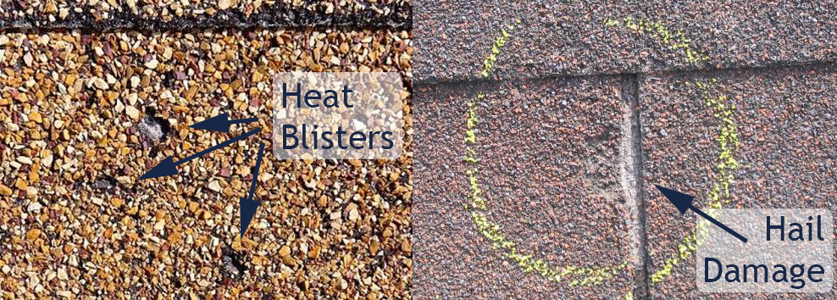

Wind Damaged Roofs
- Wind damage typically includes tearing, bending, and creasing to shingles.
- Wind damage to tile roofs can consist of tiles being blown loose from the mortar patty or nails, or tiles damaged by flying debris.

Unsealed Shingles
For claims involving unsealed shingles, please note that TWIA/TFPA Policies cover only damage caused by windstorm or hail. Properly sealed composition shingles are intended to resist significant wind events. A composition shingle that was properly sealed prior to the storm and then is unsealed by windstorm is covered damage. However, some composition shingles may not seal at the time of installation for reasons such as seal strip contamination, installation errors, manufacturing defects and cold weather installation. In the absence of other indications of covered damage, lifted/non-sealed tabs alone are not necessarily indications of wind damage. Please be sure to verify collateral damage and review weather data to properly assess unsealed shingles and wind damage.

Storm Created Openings & Wind Driven Rain
Under the TWIA and TFPA policy, wind driven rain is not automatically covered. TWIA endorsement 320 must be added in order for wind driven rain to be covered.
The following policies require a storm created opening in order for there to be any coverage for wind driven rain.
  - All TFPA Policies
  - TWIA policies with 411 (mobile/manufactured home) endorsement.
  - TWIA policies without 320 endorsement
  - All Commercial policies
A storm created opening can consist of but is not limited to a wind damaged roof vent, missing shingles or a puncture in the roof from a fallen tree. It is important to confirm that any interior damage is a direct result of the exterior wind and/or hail damage. Be sure to document your findings in the General Loss Report and include the proper diagramming located here to confirm the causation of damage.
Example 1: if you have a turbine vent that has blown off and allowed water to be blown in during a wind event, then the ensuing water damage would be covered due to a storm created opening. However, if the interior damage is on the opposite side of the turbine vent, it is reasonable to believe that the interior damage is not from the storm created opening and would not be covered.
Example 2: If the caulking around a pipe jack has deteriorated and water has seeped through during a windstorm, the interior damage would only be covered under the TWIA policy if they have a 320 endorsement.

Siding/Paint/Stucco
These claims should be evaluated on the basis of each individual elevation:
- Only the damaged elevations should be repaired or replaced.
- When one elevation of siding is replaced, TWIA does not automatically owe to replace any other elevations in order to match the new siding (see Like, Kind & Quality topic).
- When there is an insulation board or house wrap behind the siding, the insulation is expected to be damaged in the process of repairing the siding. Therefore, the insulation board or house wrap should be included in the estimate.
- When diagramming exterior wall damage, the Field Adjuster should include both damaged and undamaged elevations.

Pools

Filling
While many pools are covered under the Other Structures section of the policy (Coverage A), the water contained within pools is considered Personal Property (Coverage B). When estimating to drain a pool to perform covered repairs, the Field Adjuster should separately estimate the cost to re-fill the pool with water and the appropriate chemicals. The cost of the water can be obtained in various ways; from the local water authority, from a pool company or from the Insured’s water bill.
The cost of the water and appropriate chemicals should be listed separately and not depreciated as it should be considered for payment under any available Personal Property Coverage.

Pool Decking
Pool decking repairs should be estimated similarly to sidewalk/driveway repairs. However, the extent of repair to any deck surface material should also be evaluated to provide for a uniform appearance.

Fences
- Fences should be measured to the nearest linear foot.
- Blown down wood, aluminum, or vinyl fencing can be reset depending on the severity of damage to the panel.
  - Detaching and resetting of wood fences can generally be estimated by 8’ sections or actual linear feet (LF).
- Leaning fences if damaged by a covered peril is covered damage and should be estimated for.
- When an entire fence run (corner post to corner post) is damaged and needs to be replaced, it is considered a “replacement” and the material should be depreciated.
- Be sure that if applying depreciation, the depreciation is non-recoverable as fences are covered at ACV.
- When only a section of a fence run is damaged and needs to be replaced, it is considered a “repair” and no depreciation applied (in accordance with depreciation guidelines on page 35 that repair should not be depreciated).
- When estimating for a fence, it should be broken down on a run by run basis.

Shared/Common Fences
TWIA only owes for the Insured’s interest of a common fence. (i.e. ½ of a “good neighbor” or other shared fence). If there is a fence which appears to be on the property line, then only 50% of the repair/replacement should be allotted for in the estimate. It is reasonable to assume, that in the majority of subdivisions, the fences between properties are shared/common fences. In more rural areas where the property line is not clear, good judgement along with information provided by the insured should be used to determine if it is a shared fence. If you are unable to make a decision, please document your file and get clarification from the Claims Examiner.
If under any circumstance the insured can provide documentation that shows they are the sole owner of the fence or they replaced a certain section on their own, then we may pay for the full repair and/or replacement subject to any applicable depreciation.
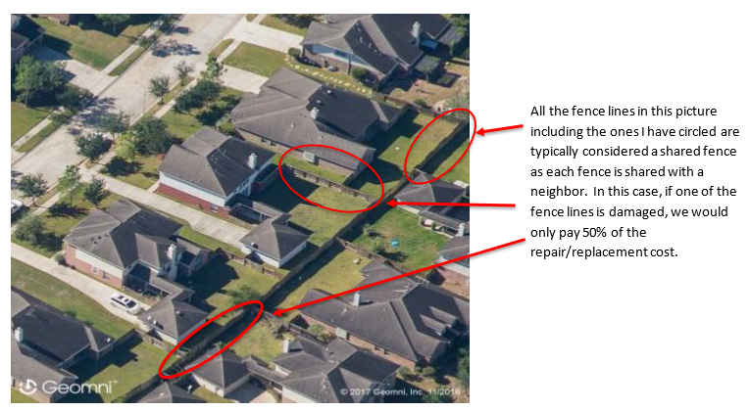

Sheds, Outbuildings, and Other Structures
Determine if the structure qualifies as an Other Structure (Coverage A) or Personal Property (Coverage B):
- The Structure qualifies as an Other Structure (Coverage A) when:
  - It is a permanent part of the realty, has a foundation, has tie downs, or is in some other way affixed to the realty.
  - If it was removed it would deface the property, such as when it has been landscaped around making it impossible to be easily removed.
- The structure qualifies as Personal Property (Coverage B) when:
  - It is manufactured to be easily moved, such as pre-fabricated plastic storage units, or is placed on skids for easy transport

Pricing for sheds, other outbuildings, and other structures:
- When the price for a prefabricated structure is available in Xactimate, the Field Adjuster should match the features in the Xactimate Selector Code with the features of the damaged shed.
- If the Insured's structure has more features than the Xactimate structure, a “stick built” estimate should be written to reconstruct the structure.
- When appropriate, the Field Adjuster should consider using general demolition rather than using the "remove" operation in Xactimate.

Retaining Walls
- Claims for damaged retaining walls should be thoroughly investigated as they are typically damaged by perils such as earth movement, wave action or surface water which are not covered by a TWIA/TFPA policy.
- If the cause of loss to the retaining wall is questionable, please contact the Claims Examiner. They may determine if it is appropriate to hire an expert to perform a professional evaluation regarding the cause of damage.

Breakaway Walls
TWIA’s policy does not cover breakaway walls:
PROPERTY NOT COVERED
We do not cover:
10. Breakaway walls, or personal property contained within a breakaway wall enclosure. Breakaway wall means a wall that is not a part of the structural support of the building and is intended through its design and construction to collapse under specific lateral loading forces, without causing damage to the elevated portion of the building or supporting foundation systems.
The determination of what is a breakaway wall and what is not a breakaway wall on homes elevated above Base Flood Elevation (BFE) can be difficult, particularly during a catastrophe event.
- The adjuster should scope ALL damage, including that below BFE. Damages below BFE should be documented as their own section in the Xactimate claim tree.
- The adjuster should discuss with the insured whether or not that portion of the structure is a breakaway wall. The property’s Flood Zone should also be documented in the General Loss Report.
- The adjuster should photograph and document the interior space below BFE, whether it has been finished, whether it’s a living space, etc.
- If the interior space below BFE is finished and/or is a living space, document your conversation with the insured concerning whether this work was properly permitted.
- If exposed, take a photo of the bottom plate connection (bolt/nail) to demonstrate how it is connected. Please see example photo below.
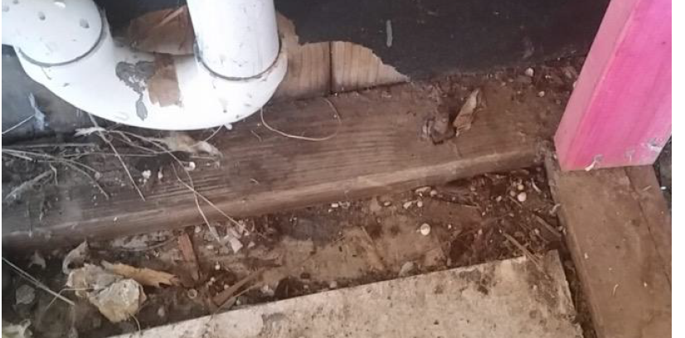

Metal Screen Enclosures
Metal Screen Enclosures are not covered per the TWIA Dwelling Policy under PROPERTY NOT COVERED 8.c.
Our interpretation of a metal screen enclosure follows the International Residential Code, Appendix H, which defines a screen enclosure as “A building or part thereof, in whole or in part self-supporting, and having walls of insect screening and a roof of insect screening, plastic, aluminum, or similar lightweight material”.
The determination of what is or is not a metal screen enclosure should be determined by the Claims Examiner. When encountering this situation on a claim the adjuster should:
- Scope all damage, including damage to the metal screen enclosure.
- The damages to the metal screen enclosure should be broken out in the Xactimate estimate in its own section.
the adjuster should not discuss whether the metal screen enclosure is covered or not with the insured.
Screen Porch - Covered Screen Enclosure – Not Covered
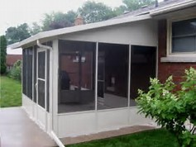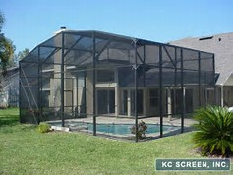

Interior Damages

Remediation

Water
On claims that have extensive interior water damage, it is recommended that the Field Adjuster include water remediation in the estimate if the Insured has not already contacted a water remediation company.
The field adjuster should not assist the insured with the selection of a water mitigation company or any other professional contractor as it is solely the responsibility of the insured. Even if the insured has not contacted a water remediation company at the time of inspection, the Field Adjuster must not select or employ a water remediation company on behalf of the customer.
If the Insured has called out a remediation company before the Field Adjuster has had the opportunity to inspect, then the Field Adjuster should write a comparative estimate once the remediation bill is received to determine whether the invoice is reasonable. This comparison estimate should be clearly labeled and uploaded with the Xactimate estimate.
It is extremely important for the Field Adjuster to monitor remediation efforts so that fans, dehumidifiers, negative air machines, etc. are used appropriately.

Mold
If the property has both covered water damage and non-covered mold growth, the adjuster’s estimate should include the cost of ordinary water damage repairs, not the increased cost associated with mold remediation or testing. On a covered loss where mold is present, the Field Adjuster should immediately notify the Insured of the mold and their responsibility to mitigate any further damage.
The application of anti-microbial agent is a preventative measure and should not be considered a part of mold remediation.

Asbestos
TWIA/TFPA’s policies do not cover any loss or damage caused by or resulting from asbestos. We do cover direct physical loss caused by windstorm or hail to covered property containing asbestos materials; however, we do not cover the additional cost or expense to test for, monitor, clean up, remove, contain, treat, abate or assess the effects of asbestos or asbestos-containing materials.
If the property has covered damage to the asbestos-containing materials, the adjuster’s estimate should include the cost of ordinary repair or replacement, but not the increased cost associated with asbestos testing, monitoring, containment or abatement.

Natural Breaks
The Field Adjuster should allow for repairs to adjoining undamaged areas if there is no natural break between the damaged and undamaged areas. Adjoining areas are connected rooms or elevations with no natural break to separate the rooms or elevations.
A natural break separating interior rooms could be a wall separating multiple rooms, a soffit wall/ceiling, a transition strip, differences in surface material (floor, wall, ceiling), or floor levels (1st story vs. 2nd story). A natural break on the exterior of the home could be a different directional roof slope or elevation.

Drywall
There are many types of drywall, so the Field Adjuster should determine the correct grade and/or makeup of the wall or ceiling surface.
- Types of drywall include: fire rated drywall, Type-X, and green-board.
- In moisture prone areas, such as a bathroom, the Field Adjuster would use green-board unless the investigation shows it was not present prior to the loss.
The Field Adjuster should estimate the actual drywall material damaged and not round up to the nearest whole sheet of drywall. A small amount of waste may be allowed when replacing drywall.
It is TWIA/TFPA’s general policy to cut out and remove the ceiling/wall surface exposed to water damage rather than sealing and painting. For minor water stains that have already dried, sealing and painting may be appropriate.

Plaster
Since there are many types of plaster/backer material/lath combinations, the Field Adjuster needs to determine the correct grade and/or makeup of the wall or ceiling surface.
- The most appropriate way to determine which Xactimate selector code to use is to examine the backer material or lath behind the plaster.
- Wood lath is common in homes built before the 1940s. Metal lath is common in homes built after the 1940s. The most common backer material used today is 1/2" gypsum board.
- The Field Adjuster would estimate replacement of like kind and quality. If the Field Adjuster is unable to determine the type of material, 1/2" gypsum board should be used.
When estimating to repair an isolated area of plaster on a wall or ceiling surface, estimate for the actual square footage of repair and include for a thin coat of plaster over the entire surface of the wall or ceiling that is being repaired.

Wall Coverings

Paint
- When drywall is replaced, the newly installed drywall should be painted with a sealer and all walls painted with two coats of paint. This includes any adjacent walls that continue without a natural break.
- Rooms with large or long walls and those with large amounts of natural light such as a great room may require more than one coat of paint.
- All openings over 50% of area being repaired or areas not requiring painting (such as behind cabinets) should be deducted when estimating for painting.
When plaster is replaced, all repaired walls or ceilings would also require two coats of paint due to the differing absorption rates of plaster and drywall.
Extra coats should be allowed when walls are custom painted, have an unusual finish, or for any other appropriate reason. Document rationale in GLR.
Content Manipulation may be allowed when:
- It would be unacceptable to move the contents to the middle of the room and cover with a drop cloth. Rooms with large numbers of items on the walls or with very large furnishings may require additional content manipulation.
An allowance for extra masking may be appropriate in rooms with chair rails, picture rails, or base and crown molding. Switch/outlet covers and dropping of standard light fixtures are included in the paint price in Xactimate.

Wall and Ceiling Texture
- The accepted repair technique for popcorn ceiling texture is to scrape and re-texture the entire ceiling. When applying popcorn texture to new drywall, the drywall should first be sealed as a separate operation to allow the popcorn texture to adhere to the new drywall. Painting is not required as it is included in the texture application.
- Many of the hand textures used on ceiling surfaces and walls can be spot replaced and the texture blended into the existing texture.

Wallpaper
- If any portion of wallpaper is damaged, the wallpaper to all adjacent walls should be removed and replaced. Should any of the adjacent walls continue without a natural break into any adjoining room(s), the adjoining room(s)' walls should also have the wallpaper removed and replaced.
- Since waste is included in the wallpaper price in Xactimate, no additional waste should be calculated except in unusual circumstances.
- Wallpaper prep (WPR PREP) should be required when replacing wallpaper

Flooring

Carpet
Carpet replacement should be estimated using the drop and fill method in the direction that has the least number of seams.
Field Adjusters need to identify the quality of material, as the grade of the damaged carpet is an important factor in estimating the replacement cost. The different grades/styles of carpet can be found in Xactimate along with images that show specific examples.
It is acceptable to allow for content manipulation to replace carpeting. Carpet should be replaced to a natural break such as flooring material transition, etc.
If the carpet is not permanently stained or delaminated, then it is possible that the carpet can be cleaned and deodorized by a professional. If the carpet is salvageable, allowances to detach and reset the carpet, to replace the carpet pad and for germicide may be required.

Wood Floors
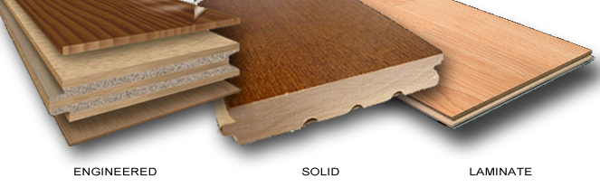
Field Adjusters should be able to distinguish hardwood floors from engineered and laminate floors due to high variances in price, quality, and repair options depending on type and quality of the flooring.
When replacing wood floor, it should be replaced to a natural break (flooring material transition, etc.). It is generally difficult to stop at doorways unless there is a clear transition. If strip flooring runs under a door, proper estimating may require an estimate to extend into another room.

Hardwood
Generally, repairs to damaged hardwood floors can be isolated to the damaged planks. These planks can be removed and replaced and the floor sanded, stained, and refinished to match. It is important to identify the cause of loss to wood floors since wood flooring can be damaged by non-covered causes such as warping from humidity, surface water, improper installation, etc.
The Field Adjuster should evaluate the level of damage to the hard wood floors as hardwood floors can be sanded and refinished without replacing the actual wood. This is dependent on the extent of damage and the number of times the wood floor has previously been sanded and refinished.
When estimating to sand, stain, and finish hard wood flooring some items that need to be taken into consideration are:
- Refinishing the floor up to a natural break
- Content manipulation as appropriate
- The machinery used to sand, stain, and refinish wood floors may mar baseboards causing them to be damaged, so appropriate repairs or replacement should be allowed
- A light post-repair cleaning may be necessary
- Masking/Dustless sanding

Laminate
Laminate flooring is more difficult to repair as it cannot be sanded. It may be difficult to match laminate flooring, even if the same brand/type of floor can be obtained, since the new floor will be from a different dye lot, resulting in a product color that may not match. If the Insured has enough extra materials left over from the original installation, it may be appropriate to estimate for a repair.

Engineered
For engineered hardwood flooring, the type and manufacturer of engineered flooring often determines the reparability. Some manufacturers give a warranty of 1 to 3 sandings for the lifetime of the engineered wood. The Field Adjuster may need to research to determine if the engineered flooring can be refinished.

Tile Floors
Tile floors are resistant to water; therefore, replacement should not be necessary unless the mortar bed/thinset is compromised or it is cracked from a covered peril. Modern construction methods use thinset rather than mortar beds and this should be considered in the estimation of repairs.
If tile needs to be replaced, the Field Adjuster should research to determine if replacement tiles can be located or manufactured. In addition, the Field Adjuster should ask the Insured:
- If they have any extra materials left over from the original installation.
- The name of the store where the tile was purchased.
- The name and contact information of the company that installed the tile.
If it is possible to repair with matching tiles, it is appropriate to estimate for only the square footage of damaged tile. If repairs are not an option, then replacement should be made to a natural break.
Sometimes claims are made for discolored tile. If discoloration due to a covered cause of loss is noted, it may be necessary to have the tile professionally cleaned to determine if it is truly stained. Discoloration of grout can be cleaned very easily. If the discoloration is a result of a covered loss, tile can be re-grouted without having to replace the tiles.
Hollow sounds under tile are not necessarily an indication of damage.

Vinyl Floors
The drop and fill method should be used for computing the replacement of vinyl flooring sheet goods. Damage due to tears, burns, and stains caused by a covered loss generally requires replacement of the vinyl floors. Vinyl tile can sometimes be repaired if the materials are still available.

Multiple Layers of Floor Coverings
If there are multiple layers of flooring, only the top layer should be considered for like, kind and quality replacement.
- If an Insured has laid carpet over wood plank flooring, the wood floor may be considered abandoned and we would only owe to replace the carpet. If there is material under the carpet that was also damaged, it should be considered on a functional basis.
- If the wood plank sub-floor was damaged and requires replacement, it may be replaced to provide a solid sub-floor and restore the Insured to pre-loss condition, but the abandoned wood floor should not be refinished.
- If an Insured chose to leave an old glue-down carpet in place and laid new carpet over the top of the old carpet, this Insured has abandoned the glue-down carpet as a functional carpet but has retained this carpet as a functional pad for the new carpet. If there is covered water loss that damages both carpets, TWIA/TFPA may consider the new carpet for replacement and the abandoned carpet that was also water damaged may be considered for removal and replacement with a comparable carpet pad.

ITEL
Xactimate’s standard and average grade pricing for flooring is typically adequate for most normal home construction and ITEL should not be warranted. However, if covered property is of a high-quality construction or a dispute arises about the grade of material, field adjusters should use an expert service for material identification such as ITEL to ensure that we allow for like/kind/quality materials in the repairs
ITEL expenses should be billed as an expense, even if the adjuster otherwise bills according to the Gross Loss Fee Schedule. Do not instruct ITEL to bill TWIA/TFPA separately, all invoices should be paid by the Field Adjuster.

Electrical

Water Damage to Electrical Fixtures
If there is evidence that water has passed through an electrical fixture, such as a light or ceiling fan, it is generally most cost effective to remove and replace the light fixture. For high value fixtures, consideration may be given to hiring an electrician to determine if the fixture(s) require replacement.

Insurable Interest
The insurable interest of certain electrical items must be verified with local municipalities/utility companies prior to including them on estimates. The Field Adjuster should verify that the Insured is responsible for that particular electrical item before making an allowance to repair or replace it.

HVAC
On all wind and hail claims, the Field Adjuster should document the make/model/age of the exterior condenser unit. A photograph of the plate with information in the photo caption is sufficient.

Repairability Reports
For a loss to an A/C unit, the Field Adjuster may consider obtaining a cause of loss and reparability report.

Repairability
If it is recommended to replace an air handler when a compressor is damaged, please contact the Claims Examiner. They may determine whether or not an expert should evaluate further.

Ductwork
Prior to replacing ducts on a covered loss, the Field Adjuster should explore all remediation and cleaning options available.

Mobile/Manufactured Homes
The attachment of the TWIA 411 Endorsement converts the HB-3 policy to a Manufactured Home Policy. These claims should be triaged to Field Adjusters with prior Mobile/Manufactured Home experience.
Please read this endorsement carefully and thoroughly as there are many exclusions for items typically covered under the HB-3 policy. Wind and Hail continue to be the only covered perils. Please note that additional endorsements such as the 320 and 365 are not applicable and cannot be added to a Mobile/Manufactured Home Policy.
Mobile/Manufactured Home policy is ACV
On policies with the 411 endorsement, Coverage A (Dwelling) is deleted and replaced with the following policy language:
We Cover:
The dwelling on the described location shown in the Declarations, used principally for dwelling purposes, including structures attached to the dwelling.

The Property Not Covered section has also changed to the following:

We do not cover:
8. The following property, all whether permanently attached to the dwelling or not:

- Awnings and carports
- Patio covers, screening and supports, enclosing or partially enclosing pools, patios, porches or other areas;
- Greenhouses, hot houses, slat houses, trellises, pergolas, cabanas, and their contents;
- Wharfs, docks, piers, boathouses, bulkheads or other buildings or structures located wholly or partially over water, and their contents;
- Outdoor radio or television antennas, or satellite signal receiving equipment including their lead-in wiring, dishes, masts or towers;
- Fences;
- Seawalls, property line and similar walls;
- Lawns, trees, shrubs or plants;
- Paint or waterproofing material applied to the exterior of the dwelling, structures attached to the dwelling or other structures covered by this policy
- Wind turbines

An example of property not covered under the 411 Endorsement is the patio cover seen below. Even though it is attached to the dwelling, patio covers are a part of the listed property we do not cover whether or not attached to the dwelling.

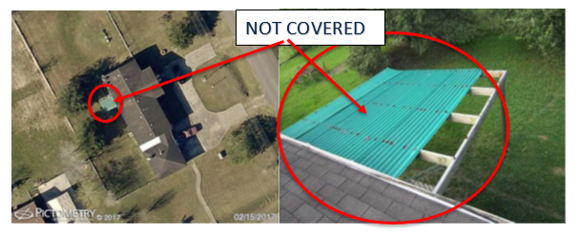

Wind Driven Rain
Under the Mobile/Manufactured home policy there is NO coverage for wind driven rain. In order for there to be any coverage for interior damage, there has to be a storm created opening. Please be sure to confirm the causation of any/all interior water damage. This should be clearly documented in the General Loss Report along with a diagram that shows the storm created opening in relation to the interior damage.
If causation is not clearly defined, the file may be sent back for interpretation.

Re-leveling
Estimates should include the Xactimate price to re-level the mobile home as well as any applicable tie downs and anchors. If the concrete piers are shifted, it is appropriate to use the Xactimate line item that allows for re-setting the concrete piers. The estimate for re-leveling the mobile home should include detaching and resetting skirting, if it is not already blown off.
If the mobile home is a double-wide, the roof ridge and interior must be inspected for splitting. If the roof ridge is split, then the Field Adjuster should estimate for roofing repairs and to bolt the two halves back together. This can be estimated by replacing the ridge board, which would provide for all access, and jacks for each side of the home.
When inspecting the mobile home for wind damage, all windows and doors should be evaluated to determine if the home has shifted.

Interior
Walls in many mobile homes are constructed of mobile home specific wallboard and not standard drywall. This type of wallboard should be estimated by the sheet not by the actual square footage. Newly constructed mobile homes may be constructed with drywall.

Xactimate Grades for Mobile Homes
- For mobile homes built in the 1970s and 1980s, standard grade should be used in Xactimate for each line item, unless the material has been upgraded.
- For mobile homes built in the 1990s and beyond, average grade should be used in Xactimate for each line item, unless the material has been upgraded.

Condo Handling Guidelines
- On the initial contact obtain the name/address of the Condominium and/or Association
- Obtain a copy of the bylaws (this should be mentioned in the initial contact)
- Scope all damage
- Consult with Claims Examiner
In many cases when handling a condo claim, coverage cannot be determined until the bylaws are received and reviewed. It is important that during the inspection the adjuster gets a full scope of all claimed damages so when coverage is determined they are able to write a comprehensive estimate without having to complete a re-inspection.

Personal Property
The Field Adjuster should keep in constant contact with the Claims Examiner to report any information they obtain regarding personal property. The Field Adjuster should address the possible damage to personal property with the Insured at the time of initial contact to determine the amount and nature of property being claimed.
If personal property is involved, the field adjuster should always assess and photo document the claimed damages.

Field Adjuster Handling – Losses under $1,500
If damage to personal property is minimal and under $1,500, the Field Adjuster should include appropriate line items for the items in their Xactimate estimate, assigned to the correct coverage (with applicable limits and deductible applied). Documentation for how the price was estimated for should also be addressed in their General Loss Report and be included with their inspection report, including receipts from the insured and/or online price matching of like kind and quality items.

Claims Examiner Handling – Losses over $1,500
If the damages are over $1,500 the Field Adjuster should provide the insured with a copy of the Personal Property Inventory Form and take photos of the damaged property. Advise the insured that you will be in contact with the Claims Examiner who will provide further direction. Contact the Claims Examiner and advise of your findings. At that time, the Claims Examiner may determine if additional resources are needed for contents evaluation and handle directly with the insured.
For extensive personal property losses (i.e. fires), TWIA/TFPA may employ the services of a separate contents vendor to expedite the claim and best serve the insured.

Field Adjuster Expectations for Personal Property Handling
- Field Adjuster should provide a copy of the Personal Property Inventory Form to the insured when personal property damage has been identified.
- Instruct the insured not to dispose of any damaged personal property prior to a planned inspection.
- During high claim volume when inspections are delayed, please instruct the insured to take photos of any damaged personal property prior to discarding.
- Document loss of personal property with adequate, annotated, and clear photos. Photos should include model or serial numbers if available. If it is not possible to take photos, the explanation should be documented in the claim log.
- For electronics, the Field Adjuster needs to determine if a certified repair technician should be utilized to determine cause of loss and repairability of an item.
- Consider Restoration, cleaning, or repairs for clothing, rugs, jewelry, furniture, collectibles, tools or paintings prior to making a recommendation for payment on any of these items.
- See specific handling guidelines for Theft, VMM and Lightning below

Theft, Vandalism & Malicious Mischief, and Lightning
If assigned a claim for Theft, Vandalism & Malicious Mischief, or Lightning it is important that the Field Adjuster communicate with the Claims Examiner to receive special instructions. The Claims Examiner must be contacted prior to inspecting the loss.
A roof inspection is not necessary on a theft or vandalism claim unless it is relevant to the method of entry or was damaged in some way from the loss. Therefore, an aerial imagery report does not need to be ordered on these claims.

Theft
Upon initial contact prior to the inspection, the Field Adjuster should ask the insured to compile all supporting documentation they may have regarding the loss. Supporting documentation that needs to be photographed can be in the form of receipts, boxes, owner’s manuals, invoices, remote controls, or any documentation that could prove ownership.
The Field Adjuster is required to photograph every room in the home to document damage or the lack thereof. For loss by theft, the Field Adjuster should also photograph areas from which the items were taken (i.e. empty TV stand showing the wires and cables, open china cabinet where silver was kept, etc.). It is important to use critical thinking when taking these photos. Does the item that is being claimed fit in this area? Are there any imprints or dust marks showing where the item was? If there are any inconsistencies, the Claims Adjuster should be contacted as soon as possible to discuss.
A police report needs to be ordered by the Field Adjuster within 24 hours of receiving the claim. The police report should be forwarded to the Claims Examiner upon receipt. Submission of a completed estimate, however, should not be delayed pending the police report.
Recorded statements are taken by the Claims Examiners or our Special Investigations Unit, not the Field Adjuster.

Vandalism & Malicious Mischief
The Field Adjuster should provide detailed photographs showing the method of entry. If the door or window has already been replaced, there should be a photo of the repair receipt. Just as any other claim, elevations, fences, attics, and other
structures need to be addressed regardless of damage. If the insured took photos of the damage prior to the repair, please request copies from the insured, or photograph them and submit with the estimate.

Vacancy
Effective November 28, 2016 the TFPA Dwelling and Homeowner’s policy was amended to use the defined term vacant in the vacancy exclusion.
“Vacant” means:
- The insured or a tenant of the insured moves from the dwelling and a substantial part of the personal property is removed from that dwelling; or
- The dwelling is unoccupied by the insured or a tenant of the insured; or
- The dwelling lacks the necessary amenities, adequate furnishings, utilities and services to permit occupancy of the dwelling as a residence.
It is important that if a property appears to be vacant that the Field Adjuster inspect additional elements. It is important to note if the electricity is on, and if not, how long it has been off. The Field Adjuster should photograph every room in the home to allow the Claims Examiner to see what contents are still in the home (i.e. appliances, cleaning supplies, etc.). If the home is for sale, information on how long it has been up for sale, and how long it has been empty of contents should be requested from the insured.
If the dwelling appears to be vacant, do not discuss coverage with the policyholder. Continue with your inspection and evaluation of the reported damaged. Once the inspection is complete, report your findings to the Claims Examiner who will review further and determine applicable coverage.

Copper Wiring on a TDP-1 Policy
In a Vandalism and Malicious Mischief claim including the theft of previously installed copper wiring on a Texas Dwelling Policy, the estimate written by the Field Adjuster should include the pricing of copper wiring as it is considered damage to the building.

Lightning
Aside from the required inspection of elevations, other structures, and interior rooms of the home, when there is a loss by lightning, the Field Adjuster should check all major appliances and electronics in the home. Even if an insured states that only their tree was damaged, the Field Adjuster should confirm that TVs, HVAC system, microwaves, stereos, indoor and outdoor lights, etc., are in working order.
If the home or a tree was struck by lightning, it is important to show detailed photos of the damaged area. Trees usually have a unique pattern confirming lightning. If the tree has fallen, include the cost of removal of the tree. Refer to the policy when considering coverage for replacing trees as there may be coverage limitations. Inside the home, circuit breakers and outlets throughout the home should be checked for burn marks.
If there is no evidence of lighting, the Field Adjuster needs to contact the Claims Examiner immediately. If assistance is needed in investigating the cause of loss, the Claims Examiner may employ an expert.

Identification of Building items versus Personal Property
The following lists are intended to help determine which items are normally considered part of the Building and which are normally considered Personal Property.

BUILDING ITEMS
Furnaces | Wall mirror permanently installed
Elevator equipment | Fire sprinkler system
Garbage disposal units | Pumps, related machinery
Built-in ranges and stoves | Radiators
Lighting fixtures | Venetian blinds
Permanently installed A/C Units | Carpet permanently installed
Built-in dishwasher | Water heaters (including solar)
Built-in microwave ovens | Plumbing fixtures
Cabinets | Permanently installed bookcases, etc.
PERSONAL PROPERTY ITEMS
Window/Portable A/C Units | Portable dishwashers
Food freezers (unless built-in) | Refrigerators (unless built-in)
Rugs & Carpet not permanently installed | Clothes washers and dryers
Portable microwave ovens, barbeque grills, similar items | Outdoor equipment/furniture (check the policy for details) residence premises

Estimating
Field Adjusters are expected to create their own estimates based on damages observed during the inspection. If you need to consult with a contractor, jointly inspect the loss with an independent contractor assigned by the Claims Examiner.
You should not recommend contractors to the insured. If asked, inform the insured that you are not recommending or hiring a contractor—it is the insured’s choice and obligation.
There should be a separate estimate per item of insurance involved. Estimates should be clearly marked as to which item they represent (i.e. Item 1 - dwelling, Item 2 – detached garage etc.). Split your items within the Xactimate Claim tree applying proper coverage limits and deductibles to the applicable item number.
Specifically, the estimate should be broken down into the following exposures (if applicable):
Coverage A
- Dwelling
- Other Structures *
Coverage B
- Personal Property
- Food Spoilage
* Even though Other Structures is a part of Coverage A (Dwelling) it should be identified and broken down separately in your estimate. The total limit of liability for other structures is 10% of the Coverage A (Dwelling) limit of liability. This is not additional insurance and does not increase the Coverage A (Dwelling) limit of liability. In cases where a limit of liability may be applied to Other Structures, the Coverage A deductible should be applied to Other Structures, rather than Dwelling.

Like Kind and Quality
All estimates should reflect replacement of damaged materials with the same materials and level of quality. If the damaged material is no longer manufactured, use the closest available materials and quality but in no case use materials of lesser quality.

General Estimate Guidelines
- Field Adjusters are expected to prepare computer-generated estimates on all losses, as appropriate. Xactimate has been selected as the current property estimating platform for TWIA & TFPA claims.
- Estimates should begin with the exterior damages, followed by the interior. The photos should be in the same order as the estimate is written and should be labeled to match the corresponding areas in the estimate.
- Estimates should reflect the reasonable cost to repair covered damage with materials of like kind and quality at the time and location of the loss and any applicable depreciation.
- In certain cases, the individual facts of the loss and damages present may require an estimate to be written differently than these guidelines suggest. The Field Adjuster is expected to justify such deviations and document them with a line item note (F9) in the Xactimate estimate and to notify the Claims Examiner as appropriate.
- The most current price database should be used for the estimate. Be sure to use the price database for the loss location closest to the loss location from within the loss state. Xactimate will attach a local price list and you should verify that the correct price list is attached based upon the location of the property being estimated.
- Apply the proper tax rate for residential or commercial construction.
- Labor minimums should be applied per Xactimate default settings.
- Consider loss history when you are writing your estimate, making certain you do not allow for damage that has been paid for in prior claims. The Claims Examiner should provide prior claim reports for comparison.
If an item is not found in the Xactimate price guide, a local price may be used if documented and reasonable. For items that appear to be priced incorrectly based on the quality allowances in Xactimate, have localized price anomalies, or have grade differences, you are encouraged to use time and material estimating for the item and document how the price was created. Such methods may be necessary for unusual or commercial items or while working in areas with access issues. You should add the new line item under the appropriate trade for the item. Include a line item note (F9) in the Xactimate estimate to explain the reason for the deviation.
Adjusters in the field do not have the authority to discuss what damages are covered or not covered with the Insured; this is the responsibility of the Claims Examiner. The Field Adjuster’s responsibility is to make a thorough property damage evaluation and submit their recommendations to the Claims Examiner, who will review applicable policy provisions to determine the disposition of the claim.

Insured Completed Labor Hours/Repairs
For the insured’s labor to perform general clean up or temporary repairs, use the LAB LBR selector code in Xactimate. If the scope of a repair job cannot be accurately estimated in Xactimate, use skilled labor hours and add an estimate line item note (F9 note) in Xactimate.
If the insured repairs a damaged item and it is a quality, permanent repair (not a temporary repair), an estimate should be written in Xactimate for what it would cost to hire a professional contractor to perform the work. TWIA or TFPA will pay an insured what it would cost for a contractor to do the same work, neither more nor less.

Roof Estimate Guidelines
- Replacement materials should be of like kind and quality. Identify and document the type, weight, and style of the roofing material being replaced. Do not use a roof shingle gauge to identify shingle type
  - There is one scenario that TWIA and TFPA allows for an “upgrade” of materials. Due to the limited availability of 20-year 3-tab shingles, TWIA and TFPA allows for their replacement with 25-year 3-tab shingles when a covered loss exists.
- On a repair to a wood, tile, or composite shingle roof with minimal damage scattered across the roof, the Field Adjuster should use a “per shingle/tile/shake price,” depending on the condition of the roof. “Per square” price should be used if the damage is in concentrated areas.
- When most or all of an entire slope of roofing material is blown off, the tear-off allowance should be proportionally reduced or eliminated, depending on the circumstances.
- When paying to replace roofing, use separate line items for the “Remove” and “Replace” operations. The “Remove” line item should allow for the actual square footage with no waste and no rounding to the nearest bundle.
- For multiple layers, add first layer as roof tear-off allowance and the second layer tear-off on a separate line of the estimate as removal of an additional layer.
- A double layer of felt should be estimated for when the pitch of the roof is 4/12 or less.
- High charges should be applied only to the area of roof that is 2 stories or greater above grade.
- Steep charges should be used on roofs with a slope of 7/12 pitch or greater (per Xactimate line item description).
- Steep and/or multiple story charges are calculated on the square footage of the slope(s) involved.
- When replacing a roof and/or slope the following components if applicable should be R&R (whether or not damaged):
  - Felt, valley metal, drip edge, ridge vent, roof vents and pipe jacks
- If there is a satellite dish present it should be detached and reset to facilitate repairs. The appropriate calibration charge should also be accounted for in the estimate.
- For TWIA claims only, outside satellite dishes, masts, and antennas, including lead-in wiring, are not covered whether or not damaged by a covered peril. Therefore, replacement of these items should not be included if damaged.
- The following roof components should only be manipulated and/or replaced if damaged by a covered peril:
  - Ridge vent, plumbing sleeves, chimney step flashing, skylights, chimney cap sheet (tile), removal and reset of A/C unit, cooler, or antenna attached to the roof
- High profile, wood, tile and metal roofs may have additional charges for ridge cap, when necessary and should be accounted for as a separate line item.
- Except for metal and tile roofs, Xactimate line item pricing includes haul off, so no separate allowance for dumpsters should be allotted unless there are unusual circumstances. However, if multiple trades are in the estimate, a dumpster charge may be needed to accommodate all repairs.

Drip Edge
- In most cases, painting of the drip edge should not be required. Drip edge now comes in a variety of material types, sizes and colors that will meet a homeowner’s needs.
- Line item RFG DRIP should be used which allows for a pre-manufactured color galvanized drip edge.
- If the fascia and drip edge are painted to match and are of a unique color, then consider allowing an additional line item to paint the drip edge.
Roof Waste Factors:
Xactware has created the Roofing Waste tool in Xactimate to provide a more scientific roofing waste calculation. It takes into consideration the type of material being used, how the product is installed, how complex the roof design is and whether or not valleys and dormers are present. Based on the information gathered, waste should be calculated using the Roofing Waste tool in Xactimate and allowing separate line items for ridge cap shingles and starter row. The starter row should be included for both the eave and the rake, where present.
In order to use the Roofing Waste tool, you will need to update your preferences as seen below.

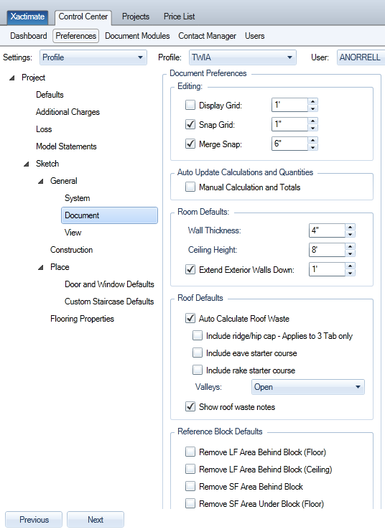

Additional Roof Loss Evaluation Considerations:

Nailable Surface
On some occasions, a claim is presented by a customer to remove and replace an underlying surface material that is not damaged by a covered cause of loss. TWIA & TFPA do not cover an underlying surface if it is aged or has a defect not attributed to a covered cause of loss, unless the outer layer of the roof was damaged by a covered peril. In the event of a covered loss to the outer surface, TWIA may pay for a nailable surface due to a defective or unusable underlayment. For example, if there is covered damage to the roof covering (shingles, tile, wood shakes, metal, etc.) and the roof decking or spaced decking has rotted, the policy generally would cover replacement of the rotten roof decking, or spaced decking and thereby provide a nailable surface to allow the repair or replacement of the roof.

Wood Roof as a Decking Material
All roofs that are damaged as a direct result of windstorm or hail with wood shake/shingle as an underlayment are to be written as follows:
- Removal of the damaged composition shingles due to direct loss from windstorm or hail.
- Removal of all additional layers of composition shingles, as specified in the code requirement to remove all layers if two or more layers are present.
- Removal of the wood roof shingles serving as a decking material for the composition shingles, as specified in the code requirement to remove all layers if two or more layers are present.
- Replacement of the wood roof decking with sheathing as specified in the code.
- Replacement of the composition shingle roof including a 15lb felt underlayment (2 layers of 15lb felt underlayment if pitch is 4/12 or below).
- Depreciation of material is based on the age, use, quality and condition of the top layer of composition shingles.

Multiple Overlay of Roofing Materials
TWIA/TFPA allow for the cost to tear off multiple layers of roofing materials and to re-deck the roof if necessary.

Footfall
If the Field Adjuster causes footfall damage to a roof during an inspection:
- Add the number of shingles, shakes, or tiles damaged by footfall plus the number of shingles, shakes, or tiles damaged by a covered peril to the estimate. The total damage is subject to the deductible.
- If there is no damage to the property or the damage is below the deductible and the Field Adjuster damages the roof by footfall, then the Insured is reimbursed for the footfall damage repair without taking a deductible.

Overhead and Profit
Overhead and profit should be included in an estimate where the customer is likely to require the services of a general contractor to repair the damage. Factors to consider in making this determination include the nature and extent of the damage, the number of trades needed to make repairs, the degree of coordination or supervision of trades required to make repairs, the opinions of subcontractors, general contractors and other experts about industry standards, and whether a repair estimate lists overhead and profit.
Each and every claim has its own merits which may make it necessary for a general contractor to supervise and coordinate the necessary trades involved. Whatever the case may be, the most important thing to remember is to document in the General Loss Report the reasoning on why OH&P may or may not be warranted.
Job Personnel Overhead (or Sub-Contractor O&P) expenses are included in the Labor Overhead portion of each unit price in the Xactware price list.

Depreciation
Good judgment should be used when determining the appropriate depreciation to apply. Depreciation should be calculated and applied on an item-by-item basis using appropriate guidelines and methods. The age of the item should be used in conjunction with depreciation tables built into Xactimate, considering reasonable remaining life expectancy, overall condition of the materials at the time of loss, market value, and other reasonable methods under a broad evidence rule.
Repairs (of covered damage) should never be depreciated.

Items Subject to Depreciation
- If an item is normally subject to both repair and replacement during the life of the structure, then the item would be subject to depreciation based upon the remaining useful life, use, wear, condition and/or obsolescence of the depreciable item. Examples include, but are not limited to, water heaters, floor coverings, interior and exterior wall finishes, and roofing materials.
- If an item is not normally repaired and/or replaced during the life of the structure, then it would not be subject to depreciation based upon remaining useful life but would be subject to depreciation based on the use, wear, condition and/or obsolescence of the depreciable item. Examples include, but are not limited to; framing, sheathing, drywall, plaster, siding, subflooring, plumbing, electrical, certain windows or doors, etc.
Depreciation must be documented when applied. Lump-sum depreciation is not accepted; it must be on an item-by-item basis based on these depreciation guidelines. Xactimate profiles should be set to a maximum of 75% depreciation.
Depreciation should not be applied to labor only items such as tear out, debris removal, tree removal, or remove and reset, etc.

Guidelines on Withholding of Recoverable Depreciation
Unless there are hidden damages, or the cost to perform the repairs at a higher cost is justified causing a supplement; the amount paid at release of the holdback will generally be the lesser of:
- The actual amount paid to perform the covered repairs; less the applicable deductible and the ACV payment
- The amount of the recoverable depreciation held back
If there are hidden covered damages discovered after the initial payment, those damages could also be subject to recoverable deprecation. The Field Adjuster should consider and evaluate situations where the actual repair cost is justifiably higher than the initial repair estimate.

Guidelines for use of Non-Recoverable Depreciation
Should you have any questions regarding the evaluation and calculation of recoverable or non-recoverable depreciation, contact your Supervisor or Manager.

Permits
To provide the most benefit to policyholders up front, adjusters should adjust their preferences in Xactimate to anticipate likely to incur permit costs on claims.
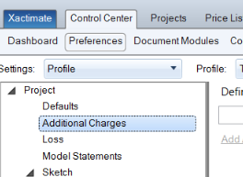

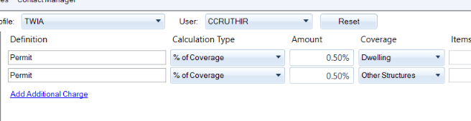
Permits should be estimated at 0.5% of the replacement cost value of repairs to structure items. This estimate is based on average permit costs using our recent historical claims data. Actual permit costs may vary by location and method of repair.

Sales Tax
Sales tax should be added and separately identified on all estimates, as appropriate. Please consult the Texas Comptroller’s website for taxable services and materials:
http://www.window.state.tx.us/taxinfo/sales/faq_collect.html

Examples of taxable items include: materials on repairs; labor on non-residential repairs (excluding property used as a family dwelling such as apartment complexes, nursing homes and retirement homes); personal property repairs; waste removal from real property. Tax should not be added to estimates for tax-exempt entities such as schools, government or non-profit organizations that have a tax-exempt certificate. The Field Adjuster must verify this. Sales tax is not depreciable.

Salvage
All salvageable items must be noted and any buy-back clearly documented.

Subrogation
All subrogation issues with Building or Personal Property items must be noted in the claim log with the subrogation explanation and rationale clearly documented. Claims Management should be immediately contacted on claims where a cause and origin expert would assist in determining subrogation.

Contractors/Public Adjusters

Contractor Estimates
The Field Adjuster has a responsibility to independently determine the cost of repairs. However, if the Field Adjuster receives a contractor’s estimate that is comparable to their own, using the same scope of repairs, a claim payment recommendation may be made based on the submitted contractor’s estimate. Both estimates need to be clearly labeled and uploaded to the file to document the basis for the payment.
If the estimate is just for a particular trade, a comparison estimate is still required and must be included in the Field Adjuster's Xactimate estimate as a line item (Example: a specific line item stating “Estimate from Bob's Roofing - $1200”).
If after completing the comparative estimate the Field Adjuster determines the contractor’s estimate is not reasonable, they should estimate the damage as they would normally, clearly addressing the differences (and similarities) between the adjuster’s estimate and contractor’s estimate. In both cases, the contractor’s estimate and the comparative estimate should be included and clearly labeled in the claim file. Final determination should be up the Claims Examiner who will evaluate all pieces of information to determine the appropriate valuation.

Hiring a Contractor
The selection of a general contractor or any other professional is solely the responsibility of the insured. The Field Adjuster must not select or employ a contractor or expert on behalf of the insured, nor recommend or coerce any insured to utilize the services of a particular contractor.

Public Adjusters
If a public adjuster has been retained by the insured and a letter of representation has not been received, the Field Adjuster should obtain a copy of the public adjuster’s contract and letter of representation and submit it to TWIA/TFPA. Even though a public adjuster has been retained, communication should always remain open with the insured and they should be advised of any updates to their claim.
Like contractor estimates, if the Field Adjuster receives a public adjuster’s estimate that is comparable to their own, using the same scope of repairs, a claim payment recommendation may be made based on the submitted public adjuster’s estimate. Both estimates need to be clearly labeled and uploaded to the file to document the basis for the payment.
If after completing the comparative estimate the Field Adjuster determines the public adjuster’s estimate is not reasonable, they should estimate the damage as they would normally. In both cases, the public adjuster’s estimate and the comparative estimate should be included and clearly labeled in the claim file.

Supplemental Payments and Supplemental Claims
A Supplemental Claim request is where a policyholder submits any new claim element not previously claimed and addressed in a notice of “claim acceptance”, “denial”, or “partial acceptance partial denial.”
A Supplemental Payment request is different from a supplemental claim request. A supplemental payment request is where a policyholder seeks additional payments for items previously claimed and addressed in a notice of claim acceptance or notice of partial claim acceptance letter.
Use of the term “supplement” is not acceptable as it does not accurately describe the type of supplement involved. While the policyholder may use the term “appeal” where they do not agree with our claim decisions, we must not use this term.
When requests for supplemental payments and/or supplemental claims are presented to Field Adjusters, the Field Adjuster should immediately contact the Claims Examiner to determine the best course of action.
The Claims Examiner should follow up with the insured to determine the reason for the supplemental claim and/or supplemental payment request, engage any necessary expert resources, and provide additional instruction to the Field Adjuster as necessary.

Appraisal Requests and Letters of Representation
- Letters of Representation from an Attorney
- Letters of Representation from a Public Adjuster
- Requests for Appraisal
- Notices of Intent to Sue
If you receive one of the above documents, please forward to twia.litigation@twia.org and copy the assigned Claims Examiner. In the email subject line, please include the claim number first, followed by the policyholder name and type of document.

XactAnalysis How-to
The following contains excerpts from XactAnalysis “Help” documents. The screen shots in this document are generic, and your company’s interface may vary.

Add a document
- Click Add Documents.
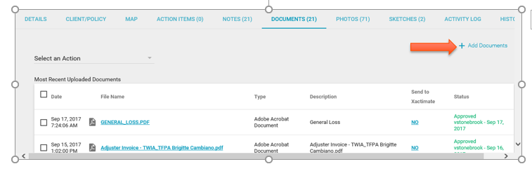
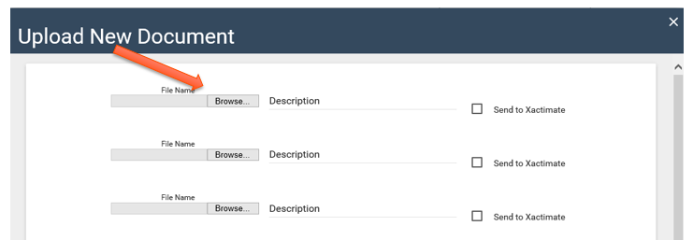
- The Upload Documents dialog box appears. Click Browse. Select files to upload.

- Type a file description in the Description field.
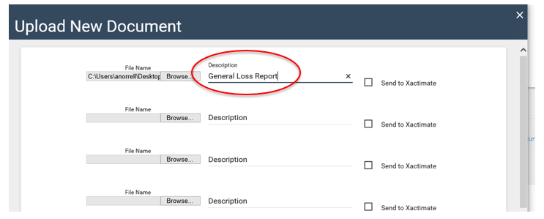
- Click Complete Upload. The documents appear in the Documents tab.
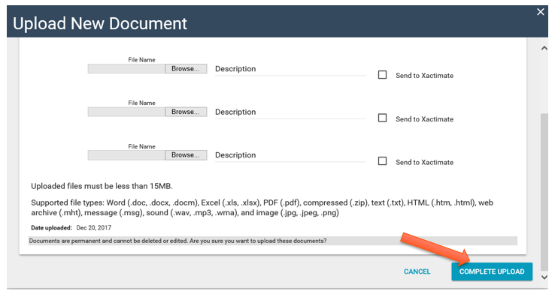

Note: Once uploaded, documents are permanent and cannot be deleted or edited.

Request EagleView Roofing Measurement Report
To send a request to EagleView for roofing measurements:
- Check the boxes of the assignments for which you want to request EagleView Roofing Measurements.
- Select Request EagleView Roofing Measurement from the Select an Action drop-down menu and click Go.
- A confirmation window appears. Click OK.
- The assignments are exported to EagleView. A notification window appears. Click OK.

QA Approve
Update the QA Approval status of selected assignments in Advanced Search Results to QA Approved. This option is not available for read-only users.
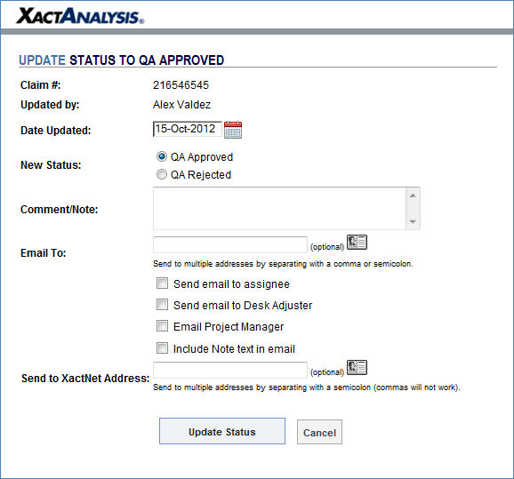
To update this status:
- Check the boxes of the assignments you want to update to QA Approved.
- Select QA Approve from the Select an Action drop-down menu and click Go.
- The Update Status to QA Approved window appears (see Figure 15). Fill out the form and click Update Status. The page refreshes, and the assignment's approval status is updated.

XactAnalysis Assignment Workflow
- A claim is reported to TWIA/TFPA.
- TWIA/TFPA creates an assignment in XactAnalysis.
- The claim is assigned to the Firm's queue.
- The Firm assigns the claim to an Adjuster (sent to their XactNet address).
- The Adjuster completes the claim in Xactimate and sends it back to XactAnalysis.
- Estimate data is added to reports.
- The estimate is reviewed in XactAnalysis.

QA Approval:
QA Approve the claim from the details tab on an individual claim basis.
When a Firm “QA Approves” the estimate in the details tab, all documents that are not marked as "rejected" are sent to the TWIA/TFPA.
If no estimate is in XactAnalysis, QA Approve the file on the details tab and this will send the status report and any other documents in the file to TWIA/TFPA.

Commercial Property Damage Evaluation Guidelines

Roles and Responsibilities

Claims Manager
The responsible claims manager will review and triage incoming commercial claims prior to the assignment of the examiner based on the complexity of the claim. The claims manager serves as an in-house resource to monitor and assist the claims examiner in bringing timely resolution to each claim.

Claims Examiner
When TWIA receives a first notice of loss (FNOL) on a commercial claim, a claims examiner reviews the policy, risk information, aerial photography, prior claims, underwriting files, and descriptions of damage to make an initial determination of the type and number of experts that may be needed during the evaluation of the claim.
As additional information is gathered, the claims examiner and independent field adjusters work together to determine what, if any, additional resources are required in the evaluation of the claim.

Independent Field Adjusters
It is the role of the independent field adjuster to gather evidence, document the windstorm or hail damage being claimed, as well as damages observed but not claimed. Independent Field Adjusters are responsible for coordinating inspections with the Insured’s representatives and the experts engaged by TWIA. The independent field adjuster will also be responsible for updating of the XactAnalysis claim file. The XactAnalysis claim file should contain progress updates in addition to expert reports, weather data, loss reports, estimates, and any other documentation obtained to investigate the claim.
One or more of the following types of independent field adjusters will be assigned to a commercial claim:

Executive General Adjuster (EGA)
The EGA is the lead independent field adjuster on the claim. The EGA works with the policyholder’s representative, the insurance agent, independent field adjusters, engineers, contractors, and other stakeholders to ensure accurate and timely claim resolutions.
With a large number of items, it is expected the EGA will use a team approach to evaluate the claim. A team approach is one in which the EGA will identify and secure a sufficient number of resources to complete a thorough investigation of the insured’s claim within as few days as possible. The EGA must contact the TWIA Claims Examiner to get approval for the number of independent field adjusters and resources being utilized to evaluate a claim. It is the responsibility of the EGA to identify and coordinate independent field adjusters as well as experts utilized on a claim to inspect, photograph, document, estimate and report on damages.

Example of a team approach model

General Adjuster (GA)
General Adjusters are, usually, assigned to handle medium-to-small commercial claims with medium-to-low anticipated complexity. General Adjusters are also assigned to report to EGAs on large complex commercial claims with multiple scheduled items and/or locations. General Adjusters may also coordinate the inspection efforts of Commercial Adjusters at the request of an EGA.

Commercial Adjuster (CA)
Commercial Adjusters are primarily assigned to work at the direction of an EGA or GA to photograph and inspect properties with a large number of buildings or a large number of residential units, such as apartment buildings, condominium buildings, and townhouses under the team approach to ensure claims are resolved within the statutory timeframes of 60 days under HB-3.

Professional Engineer (PE)
Licensed engineers are sometimes necessary to address questions about causation of damages on commercial claims. If an inspection or conversation with the insured reveals the use of an engineer is warranted, the TWIA claims examiner needs to be notified to coordinate the proper resources.

Building Consultants (BC)
On complicated or unusual repairs, a building consultant should be engaged on the claim. The building consultant will provide an evaluation of damages to the adjuster that may include, but not limited to, cost of labor and materials, bids, and estimates. It will be the job of the adjuster to coordinate these resources with any other experts and personnel involved in the claim, such as coordinating inspection times, sharing of expert reports, etc.

Independent Contractors (IC)
It may be necessary for the independent field adjuster to coordinate with independent contractors to secure bids to determine the actual cost of repair. In these cases, the adjuster acts in a similar fashion as they do with Building Consultants, coordinating inspections and documents between contractors and the policyholder.

Authority of the Policyholder’s Representative
Many commercial policies are for organizations that have many partners, managers, employees, property managers, and/or board members. It is important to make sure to identify the person with proper authority to make decisions on the behalf of the insured organization.
- When you make initial contact with a person claiming to represent the policyholder, you must specifically identify the person’s name, title, and contact information. Consider obtaining a business card and include it in your report.
- If you are dealing with anyone other than the individual named as the policyholder, ask that person if they have the authority to make final decisions regarding the claim and be sure to state his/her response in your report.
- You might find that the policyholder wants you to deal with different individuals for different properties or different aspects of the claim.
- For consistency and whenever possible, attempt to work with a single person with proper authority over all areas of the claim.
- If you must to deal with more than one person in order to provide the best service to our customer, be sure to gather all the needed information for each of them and relay it to TWIA in your report.
- Secure written documentation confirming who the contact person representing the insured is.
- If the contact person is a Public Adjuster, gather a copy of the applicable license and contract and forward to TWIA as soon as possible.
- If the contact person is an attorney, whether or not they claim to have been hired to represent the policyholder, contact the assigned TWIA examiner before proceeding.
- If you think there might be any question later regarding an individual’s authority to represent the policyholder, contact the assigned examiner and discuss the situation prior to proceeding.

Commercial Policies Insured by TWIA
TWIA assigns commercial policies to one of the following categories. There are some aspects of commercial claim handling which are universal to the types of claims being presented, in addition to the guidelines previously established in the residential property evaluation guidelines some additional considerations are:
- Confirm the insured’s authorized representative
- Confirm the buildings affected by the claim with the insured
- Confirm with TWIA the number of resources needed to complete the evaluation of the claim
- Photograph all of the insured location(s), including damaged and undamaged areas
- Secure any repair estimates, bids, maintenance logs, repair records, or other pertinent documentation.

Governmental Entities
The typical types of governmental entities insured by TWIA are county, city, port authority, housing authority, school district, municipal utility district, or other political subdivision of the State of Texas. These claims must be handled by an EGA, with a team approach. Guidelines for evaluating these types of claims are listed below:
- Confirm the insured’s authorized representative in writing
- The EGA should confirm the buildings affected by the claim with the insured in writing
- Confirm with TWIA the number of resources needed to complete the evaluation of the claim
- Secure competitive bids from Independent contractors

Essential Services
Essential Services are items covered by a TWIA policy such as hospitals, police stations, fire stations, schools, day care and assisted living facilities. Claims for these types of policies will receive the highest priority. Every effort should be made to resolve these claims as quickly as possible. An EGA using a team approach and building consultants must be utilized on these claims. A status report documenting what has been done and what remains outstanding with a tentative timeline should be submitted for review every ten days until the claim is resolved.

Condominiums, Townhouses, and Apartment Buildings
The exterior and interior of every insured condominium, townhouse, and apartment building must be inspected for damage. Condominiums, Townhouses and Apartment building claims will be handled by an EGA, with a team approach.
Claims involving condominium associations, including the sub-group townhouse associations, are complicated by the existence of two types of property within the association – “common elements” and “units.” The common elements are further subdivided into “regular common elements” and “limited common elements.” The ownership, right to use, responsibility to insure, and responsibility to maintain each of these types varies. Before TWIA can determine what portions of the loss might be covered under the association’s policy and what portions of the loss might be covered under the unit owner’s policy, it must be determined who insures what. The coverage boundaries are spelled out in legal documents that formed the condominium association. The legal documents are often called the “Conditions, Covenants, and Restrictions (CCRs),” the “By-Laws,” or the “Condo Docs.”
- You should request the condominium documents from the policyholder representative shortly after receiving the claim and preferably during your initial contact. It usually takes time to assemble and copy the information so get started on the process early.
  - However, since the documentation is the same for all unit owner claims within a condo association with multiple units, TWIA is developing a repository of the condo documents for the properties it insures. You should check with the assigned examiner to see if TWIA already has the needed documents before asking the insured. Confirm that it is the latest version or that all amendments have been included.
- It is not always clear where in the “condo docs” the “Insurance” section is found. It is often confused with the section dealing with “Maintenance,” so it is best to get the whole document, not just some of the pages.
- Although the document needed is often called the “By-laws,” there is a separate document related to the incorporation of the Association titled “By-Laws.” TWIA does not need the corporate By-Laws.
- The “By-Laws” are a large formal document officially recorded with the State and they are usually dozens of pages in length. If the association representative provides you with a document that is only a few pages long, it is unlikely to be the correct and necessary document.
- The documents written during the formation of the association are sometimes changed or amended in following years. Be sure to ask for the original document and any amendments.
- If you are handling the association’s claim, you might get calls from the TWIA adjusters handling the unit owner claims asking if you have already obtained the necessary documents. If you have already obtained the condominium documents and forwarded them to TWIA, it is not necessary for the other adjusters to obtain a copy.
- Endorsement 282 (including both the 282-1 and 282-2 versions) makes all elements of the property insured under the association’s master policy. TWIA does not need to separate common and limited common elements from the unit elements so there is no need to review the condo docs.
- If the association’s policy includes a 282 endorsement, you do not have to gather the condo docs.

Churches and Historical Buildings
EGAs are usually assigned to churches and historical buildings due to the complexity of the inspections for damages to buildings (and other scheduled structures), business personal property, and business income loss. An EGA may engage the team approach to address causation, building codes, inventory valuation, salvage, etc.

Large Commercial
Manufacturing centers, large warehouses, shopping centers and office buildings make up most of TWIA’s large commercial claims. A GA or an EGA may be assigned to a Large Commercial claim based on the size, complexity, and type of damage being claimed.

Small Commercial
TWIA’s small commercial claims, usually, consist of small-to-medium sized buildings and involve business personal property only. Most small commercial claims are assigned to GAs. Depending on the loss, Xactimate estimates may be acceptable on these claims.

Investigation and Reporting
HB-3 timelines for resolution are the same between the commercial and residential policies. As a result, many of the same guidelines found in the residential section are applicable to commercial claims. These include:
- Contact within 24 hours of assignment
- First visit/inspection to the loss location within 48 hours of assignment
- Initial/Preliminary inspection report within 72 hours of initial visit/inspection
- Status updates on a weekly basis
Due to the complexity and nature of many commercial claims and properties, there are additional considerations with respect on how to approach and conduct the investigation.

Reserve Recommendations
The initial/preliminary inspection should provide a measurable outline of all damages, which should allow the claims adjuster to project a reserve for the claim within 3-6 days of assignment.
- Losses up to $25,000 can be reported on the “Initial Inspection Report” or “Loss Report.”
- Losses over $25,000 should be reported on the full “Narrative Report,” still within three days of the initial/preliminary inspection.
Loss reserves should capture a dollar reserve for the following categories and be rounded to the nearest one hundred dollars.
The following examples illustrate how loss and expense reserves are calculated and documented when projecting reserves.
Loss Reserves/Claim Indemnity
Building – Item #4 $10,000.00
Business Personal Property– Item #5 $1,000.00
Business Income Loss $0.00
Extra Expenses $0.00
Total Loss Reserves $11,000.00

Claim Expenses
Independent Adjuster $800.00
O & C Investigation/Engineer $2,500.00
Building Consultants $1,500.00
Total Expense Reserves $4,800.00

A general disclaimer on establishing a recommended reserve should be posted with the “Initial Inspection Report” or “Narrative Report.” What follows is an example of this general disclaimer.

Important Disclaimer
The sole purpose of this report is intended only to assist the insurance carrier with establishing reserve(s) recommendations. The dollar amounts referenced within this report are not intended to establish settlement value, but merely to reflect the possible exposure based on our initial inspection of the property in question. Once our formal inspection and valuation of the loss has been completed, the referenced reserve recommendations may need to be adjusted. These reserve recommendations, and any future adjustments, do not take into consideration coverage(s), coverage limitations, or any other coverage analysis, nor should the mere recommendation of these reserves be construed as an acceptance of coverage or an indication that a payment for that amount would be appropriate or is being recommended.

Core Samples
Core samples may be required on low slope roofing to determine the multiple roof membranes, possible recovery boards, insulation and fastening method of the roof system. The field adjuster should not take core samples on low slope roofing.

The location of a core sample should be determined by an engineer or roofing consultant. In most cases, one core sample will be taken at the low point and another will be taken at the high point of a ridge or cricket. The appropriate expert can determine the type of roof system with the core sample and coordinate with a roofing consultant on replacement or repairability.

In a case of possible subrogation or storage of the sample core, the engineer must keep control of and invoice for the storing and security of the core sample. Prior to coring a roof, consider the effects of destructive testing to any roof system or manufacturer warranties and alert any other interested parties.

- Document discussion with the insured to determine the manufacturer and warranty in the “General Loss Report”
- If a warranty is in place, a “Certified Roofing Contractor” should be contacted to complete the sample core and complete repairs after the core is taken
- The engineer and building consultant can assist in the location of the core sample and how many core samples are required
- The General Adjuster should contact TWIA prior to any roof cores taking place
- The General Adjuster should secure a quote on the cost of taking and repairing the core sample area

Roof-Top Mounted Equipment
When inspecting the risk location, it is important to look at heating, ventilation, air conditioning, and refrigeration equipment, including ductwork, A/C mounting curbs, skids, uni-struts, and strapping details securing equipment to the roof. (See ASRAE Journal, volume 48, #3, March 2006). The independent adjuster should photo document these components.
When inspecting a risk with multiple mechanical units located on a roof-top, a mechanical building consultant may be required to scope, document, and estimate the cost of repair. Contact your Claims Examiner for further direction.

Aerial Images
Location specific aerial images, both, pre and post event, should be reviewed as part of the evaluation process.
EagleView Roof Reports are automatically requested and available for policies with a single location. When a policy includes multiple locations and/or multiple buildings per location, individual reports must be requested from and coordinated with EagleView.
- Email a request to EagleView (customerservice@eagleview.com) requesting roof reports for each building at a specific location.
- An EagleView Customer Service Representative will send an overview of the buildings at the requested address, labeling them as Buildings 1, 2, 3, etc.
- Respond to the Customer Service Representative by indicating which of TWIA’s scheduled items correspond to each of their numbered buildings. For example, Building 1 is TWIA Item 001, Building 2 is TWIA Item 003, Building 3 is not insured by TWIA, etc.
- EagleView will then generate the requested roof reports labeling with the TWIA Item numbers indicated.

Claims with a Large Number of Insured Items
Some of TWIA’s Commercial Policies include dozens or hundreds of Insured Items and locations. Following are recommendations for working these types of claims:

Narrowing the Scope of Inspection
Because commercial policies often insure multiple structures, it is important to acknowledge and address the possibility of damage to all of those insured items. Your report package must discuss each location, each building, each room, and any BPP in those rooms. If the insured identifies buildings or structures for which no claim is being made and provides a written statement stating the same, those buildings or structures and the contents within them do not need to be inspected.
- To ensure that everyone is clear which buildings or contents are not being claimed, the insured must give you a written statement declining your offer to inspect them.
- The signed statement must be from a person properly authorized to make such a decision on behalf of the insured.
- A copy of the original signed statement must be included in your report.

Confirm Coverage Afforded Under the Policy
Since TWIA policies renew yearly, the insureds can add and remove items from coverage on a regular basis. Confirm with the insured that the item listed is the item being presented for a claim. If necessary, confirm with TWIA or the insured’s agent which items were included or excluded from the policy.

Use Team Approach
An EGA will employ a team of adjusters, general adjusters, engineers and estimating experts to evaluate claims with 5 or more items/areas of inspection. The EGA will be the point of contact for both TWIA and the insured, and will coordinate all inspections, appointments, and request for information.

Uploading Large Reports
All estimates and reports should be uploaded in PDF form to XactAnalysis, through which they will be submitted to TWIA. If you have any questions, please contact the Claims Examiner assigned to the claim.
Claims with dozens or hundreds of Insured Items can get too numerous and/or voluminous to upload through XactAnalysis. Work with the TWIA Claims Examiner to create a plan for submission of items required to document the claim. Suggestions include breaking items into smaller batches (Items 1-10, Items 11-20, etc.), or using an FTP or Cloud site to upload the required information. Consider uploading both live and PDF copies of spreadsheets, so that the examiner can edit the live spreadsheet to process RCC claims and perform other tasks at a later date.

Emergency Services
If it is determined that emergency services, such as water mitigation, board-up, tarping, or generators, are advisable, immediately consult with the claims examiner to coordinate these resources. It’s important for the insured to understand that such services do not increase the limit of liability.

Evaluating the Loss
The independent field adjuster should consider all available options for completing an estimate in accordance with best practices. In many cases, an Xactimate estimate is not the preferred estimating tool. The adjuster should consider the size of loss, complexity, time needed and resources available to complete an estimate. There are several types of acceptable estimates for commercial claims, which are:
- Xactimate estimates
  - Should be used on small to medium complexity claims
  - Primarily on residential components
  - Should not be considered as the first available option on claims with an anticipated loss exceeding $100,000
  - Xactimate estimates of repair should conform to Xactimate best practices. Pay careful attention to what is included in each line item cost. For instance, the line items for removal of exterior siding, usually, do not include the disposal cost of that debris; however, the line item for the removal of asphalt shingles does include disposal cost.
  - Xactimate pricing is an estimate and guideline. Situations may arise where the pricing is not in line with the actual expected cost. Work with the claims examiner and the insured should changes to the Xactimate price list become necessary.
- Building Consultant estimates
  - Should be used on medium to complex losses
  - Can be used as part of the competitive bid process
  - The building consultant should be the expert in determining the appropriate form of estimation used for the type of claim presented
- Time and Materials
  - To be used on complex losses
  - Should be completed by a building consultant or independent contractor
- Competitive Bids
  - Should be used on complex losses and losses involving more than 1 location
  - Can use the insured contractors or independent contractors identified by the EGA, TWIA or building consultant
  - Efforts should be made to ensure the receipt of competitive bids prior to the 60-day HB 3 timeframe

Other loss evaluation guidelines:
- Split items within the estimate by applying the proper line of coverage (with appropriate limits and deductibles) to the line items to which they apply.
- Properly label the items within the estimate. For example, it would be more accurate and descriptive to label the item as “Item 1 – Fire Station #3,” instead of “Commercial.”
- The estimate should follow a similar structure as the photo report and general loss report. Begin with overview photos followed by roof photos, exterior photos, interior photos, and contents photos. Following this same pattern in the loss report and the estimate will make the file easier to review and understand.
- Interior sketches should line up with exterior sketches with correlated areas of damage clearly outlined.
- The inspection cost for securing a WPI-8 wind certificate by statute isn’t paid for by TWIA. This cost is the responsibility of the insured. However, if the windstorm engineer is required to design a plan for meeting wind code or I.B.C. – 2006 code requirements, the plan cost may be covered on an incurred basis only. Contact your Claims Examiner for further direction.
- If the independent field adjuster identifies risk factors such as, but not limited to, building code violations, safety issues, or other underwriting concerns, they should prepare an underwriting risk report to alert TWIA to these potential problems.
Consult with the Claims Examiner, who may find it necessary to instruct the independent field adjuster to work with other experts and partners on the claim to deliver an accurate estimate for repair to covered damages.

Material and Labor Sales Tax on Repair Estimates
The TWIA guidelines on including sales tax on repair cost estimates comes from the Real Property Repair and Remodeling tax publication from the Texas Comptroller of Public Accounts, which can be found on the Comptroller’s web site at http://www.window.state.tx.us/taxinfo/taxpubs/tx94_116.html. The topics that are most applicable to TWIA’s Commercial policyholders are:
Residential vs. Nonresidential Repair and Remodeling
Tax exempt Organizations
Natural Disasters

Residential vs Nonresidential Repair and Remodeling
“Labor to repair, remodel, or restore residential real property is not taxable. Residential real property means family dwellings, including apartment complexes, nursing homes, condominiums, and retirement homes. It does not include hotels or residential properties rented for periods of less than 30 days. The property does not have to be the residence of the owner.
On the other hand, the total amount charged for remodeling, repairing, or restoring nonresidential real property is taxable. Examples of nonresidential real property are hospitals, office buildings, refineries, warehouses, parking garages, retail shops, restaurants, manufacturing facilities, and other commercial establishments.”

Tax-exempt Organizations
“You don't need to charge tax when you do a job for a governmental agency - federal, State of Texas, or Texas local government. Some nonprofit organizations also are exempt from tax but must give you an exemption certificate. Other nonprofit organizations must pay sales tax. If an organization has a letter from the Comptroller of Public Accounts exempting it from sales tax, and the real property improvement relates to the exempt purpose of the organization, certain exemptions are available.”

Governmental Entities
Section 151.309 of the Texas Tax Code defines the governmental entities that are exempt from sales tax. The definition that most specifically applies to TWIA Insureds is “(5) a county, city, special district, or other political subdivisions of this state.” TWIA Policyholders that are political subdivisions of the State of Texas are counties, cities, school districts, housing authorities, port authorities, municipal utility districts, etc.

Non-profit Organizations
As mentioned above, a non-profit organization must have an exemption certificate from the Comptroller’s office to be exempt from sales tax. Independent adjusters should obtain a copy of the certificate from the insured organization. A copy of the certificate can also be obtained through the Texas Tax-Exempt Entity Search: http://window.state.tx.us/taxinfo/exempt/exempt_search.html.

Natural Disasters
“The labor to repair nonresidential property damaged in an area declared a natural disaster by the President of the United States or the Governor of Texas is not taxable. (Materials are still taxable.) The property must have been damaged by the condition that caused the area to be declared a natural disaster. The contract or billing must separately state the amount charged for labor from the amount charged for the incorporated materials.”

Sale Tax Rate
In Texas, the sales tax rate is a maximum of 8.25%. It is based on the state sales tax of 6.25% and up to 2% of taxes from counties, cities, special purpose districts and transit authorities. To determine the rate of tax that should be applied to a property at a given address, use the Comptroller’s Tax Rate Locator at https://mycpa.cpa.state.tx.us/atj/addresslookup.jsp. It is important to note that a policyholder may have different tax rate for different insured properties, depending on the rates at the individual addresses.

Commercial HB-3 Policy
TWIA policies are named-peril coverage for windstorm and hail only, with exclusions.
There are significant differences between the TWIA Dwelling and Commercial policies and significant differences between standard ISO® commercial policies and the TWIA Commercial policy. It is required that all Commercial Adjusters know the TWIA Commercial policy and endorsements, to have access to them in the field, and to refer to them often. Copies of the Commercial Policy and Endorsements can be found at http://www.twia.org.
See below for a summary of highlights from the TWIA Commercial policy

Coverage A
- TWIA policies cover the perils of windstorm and hail only. Some residential policies have coverage for indirect loss by endorsement (i.e. Consequential Loss, ALE and Wind-Driven Rain). However, commercial policies do not have this optional endorsement.
- The TWIA Commercial policy covers buildings or structures, meaning everything which is legally part of the buildings or structures described in the Declarations. However, the TWIA Commercial policy does not cover machinery which is not used solely in the service of the building.
- The TWIA Commercial policy also covers, under Coverage A, personal property that is owned by the insured, used for the service of, and located on the described location. The personal property items listed below are NOT covered if the insured is only a tenant or occupant of the building.
  - Fire extinguishing equipment;
  - Maintenance equipment and supplies;
  - Floor coverings;
  - Window shades;
  - Furnishings of corridors and stairs; and
  - Appliances used for refrigerating, ventilating, cooking, dishwashing or laundry.
- The TWIA commercial policy covers materials and supplies located on or next to the described location used to construct, alter or repair the covered building or other structures on the described location, up to a limit of 10% of liability on coverage A. This is not additional insurance and does not increase the Coverage A (Building) limit of liability.
- At the insured’s option, 10% of the limit of liability applying to boarding, rooming, fraternity or sorority houses or apartment buildings (containing 8 or less separate apartments) may be extended as excess insurance to the items listed below. This extension does not apply to structures over or partially over water, is not additional insurance, and does not increase the limit of liability.
  - Fences
  - Drives
  - Walks
  - Outdoor Fixtures
  - Garages, Employee’s Quarters and other outbuildings used in connection with any such building.
- When replacement cost applies to the building, these items are ALL estimated at replacement cost, except for carpeting, cloth awnings, window or wall air conditioning units, which are always ACV under a Commercial Policy. Non-recoverable depreciation should be applied on material only.

Coverage B
The TWIA Commercial policy covers business personal property located in or on the building, or in the open on the location, or in a vehicle or railroad car located within 100 feet of the described building, consisting of the following (unless otherwise specified in the Declarations):
- Furniture and fixtures;
- Machinery and Equipment;
- Stock, meaning merchandise held in storage or for sale, raw materials, and goods in process or finished, including supplies used in their packing or shipping;
- All other personal property owned by the insured;
- Personal property of others for which the insured is legally liable;
- Personal property of an insured’s officers, partners or employees, if not otherwise insured. (Loss or damage to the covered property will be adjusted and made payable to the insured.)
- Labor, materials or services furnished or arranged by the insured on personal property of others;
- The insured’s interest as tenant in improvements and betterments.
- The insured’s interest as unit owner in improvements and betterments made to a condominium. However, TWIA’s commercial policy does not cover property in or on the described location which is defined in the condominium’s declarations or by-laws as a common element.

Property not covered
Whereas the TWIA Dwelling Policy addresses Property Not Covered under one heading of, “We do not cover,” the TWIA Commercial Policy has two designations -- 1) Unless specifically described in the Declarations, we do not cover, and 2) We do not cover. The following chart highlights the distinctions between the two policies. Note that under the Commercial policy items fall under one of the two categories.
Residential | Commercial
1. Animals | 1a. Same
2. Money, currency or bullion.  3. Securities, deeds or evidences of debt.  4. Records, books of records or manuscripts. | 1j. Manuscripts, bullion, records and books of records (except for their physical value in blank);  2a. Accounts, currency, deeds, or other evidences of debt, money or securities.
5. Motor or engine propelled vehicles or machines designed for movement on land, including attached machinery or equipment. However, we do cover such vehicles, while located in a fully enclosed building, which are not subject to motor vehicle registration and are:  a. Devices and equipment for assisting the handicapped.  b. Power mowers and other lawn and garden equipment not exceeding 18 horsepower.  c. Golf carts.  d. Vehicles or machines used for recreational purposes while located on the described location. | 1b. Same with addition of 1b(5) Forklifts
6. Aircraft, meaning any device used or designed for flight except model or hobby aircraft not used or designed to carry people or cargo. | 1c. Same
7. Watercraft, including outboard motors and furnishings or equipment. However, we do cover watercraft, including outboard motors and furnishings or equipment while located on land in a fully enclosed building on the described location. | 1d. Same
8. Unless described in the Declarations:  a. Cloth awnings  b. Greenhouses and their contents | 1h. Greenhouses and cloth awnings
8. Unless described in the Declarations:  c. Metal screen enclosures and their contents. | 1i. Same
8. Unless described in the Declarations:  d. Buildings or structures located wholly or partially over water and their contents. | 1e. Wharves, docks, piers, boathouses, bulkheads or other structures located over or partially over water and the property in or on it.
8. Unless described in the Declarations:  e. Radio or television towers.  f. Outside satellite dishes, masts and antennas, including lead-in wiring.  g. Windmills and wind chargers. | 1f. Radio or television towers, antennas and satellite signal receiving equipment, windmills, wind chargers, and outside erected signs.
9. Wind turbines. | 2b. Same
10. Breakaway walls, or personal property contained within a breakaway wall enclosure. Breakaway wall means a wall that is not a part of the structural support of the building and is intended through its design and construction to collapse under specific lateral loading forces, without causing damage to the elevated portion of the building or supporting foundation systems. | 2c. Same with addition of business personal property.
11. Property that is covered under another coverage form of this or any other policy in which it is more specifically described, except for the excess of the amount due from the other insurance. | 2d. Same
NOT IN DWELLING POLICY | 1g. Metal smokestacks, except when securely fastened to walls of a masonry building.
NOT IN DWELLING POLICY | 1k. Customers goods in laundries, cleaning, or pressing establishments.

It is also important to note; signs attached to the outside of the building are covered. Free-standing signs must be scheduled for coverage. Always check the Assignment sheet to verify whether an item is specifically scheduled. If this information is unavailable, contact the assigned Claims Examiner.

Common Endorsements
Below is a brief description of some of the most common TWIA Commercial Endorsements. This overview is not a detailed analysis of the endorsements. Independent Field Adjusters are required to be familiar with the Commercial Policy and Endorsements. Please contact the TWIA Claims Examiner with any questions you may have.

Endorsement 164 – Replacement Cost Endorsement
Endorsement 164 applies replacement cost coverage to the items specified.
Regardless of this endorsement, there is no replacement cost coverage for:
- Stock, (raw, in process or finished) or merchandise, including materials and supplies in connection therewith;
- Property of others;
- Personal property usual to a residence;
- Books of account, manuscripts, drawings, card index systems and other records (including film, tape, disc, drum, cell and other magnetic recording or storage media);
- Paintings, etchings, pictures, tapestries, statuary, marbles, bronzes, antique furniture, rare books, antique silver, porcelains, rare glassware and bric-a-brac or other articles of art, rarity or antiquity;
- Outdoor equipment, except equipment used in the service of the building; or
- Carpeting, cloth awnings, window or wall air conditioning units.

However, if TWIA insures a church, school or hospital under this policy, replacement cost will apply to the items a-f listed above.
Policyholders have 545 days from the date of claim settlement to recover any applicable depreciation.
If there are questions or concerns regarding what items may or may not be applicable, contact the assigned claims examiner.

Endorsement 282 (1) or (2) – Condominium Property Form
The 282 endorsement is for a condo association only.
The endorsement amends the covered property to include fixtures, installations or additions of the building within the unfinished interior of the individual condominium units initially installed. The endorsement may also include coverage for those items installed by or at the expense of the unit owner.

Endorsement 17 – Business Income Form
Provides a “daily limit” or “pro rata amount” if the insured sustains a covered loss causing loss of “business income” and/or “rental value.” This coverage is applicable during the period of restoration. The endorsement also provides coverage for “extra expense” that an insured incurs during the period of restoration that they would not have incurred had there been no direct physical loss or damage to the property.
The Maximum Limit of Liability is $100,000 per building per occurrence.
Daily Limit per Working Day per Building is $50.00 per day minimum and $1,000.00 per day maximum.
Number of Working Days Covered is 60 days minimum and 365 days maximum.
The Daily Limit and Number of Working Days Covered will have been determined by the insured and their agent and submitted to TWIA with application for approval. The available coverage will be reflected on the declarations page.
The maximum amount that will be paid for “extra expense” coverage is $10,000 occurring within 365 consecutive days after the date of direct physical loss due.

Endorsement 17 waiting period
Endorsement 17 covers the loss of business income differently than the way it is covered under the more usual ISO-type policies written by other carriers, such as the “CP,” “BP,” or “BO” series of forms. One of the differences is the way that the “deductible” is handled.
- Rather than apply a dollar amount as a deductible, Endorsement 17 states the coverage does not start until 168 hours after the loss.
- This week-long waiting period starts at the moment physical damage occurs that creates the loss of business income.
- If a second covered loss occurs before the business is repaired, a waiting period is not applied to the second loss.
- To account for the waiting period, you calculate the business income loss from the date seven days after the loss until the date the building is repaired or replaced or should have been repaired with reasonable speed to its prior condition.

Endorsement 432 – Increased Cost of Construction
Endorsement 432 provides coverage for the increased costs that are incurred by an insured due to the enforcement of any ordinance or law. This endorsement is applicable to claims where a code upgrade is necessary to complete a covered repair. This is paid as incurred and it should be noted on the estimate as such.
The total limit of liability for each building item designated is shown on the actual endorsement. This is additional insurance and does not reduce the limit of liability on the policy. Some of the most common increased cost of construction items at TWIA are as follows:

Use of Composition Shingle Roofing on Low-Sloped Roofs
Composition shingle roofing may be used on slopes that are 2/12 and above. However, if the slope is from 2/12 up to and including 4/12, a double layer of felt paper must first be installed. Slopes of less than 2/12 pitch require a modified bitumen or another approved material.

Roof-Top Mounted Equipment
Roof-mounted equipment may require a wind engineer to inspect and design site-specific requirements for mounting the equipment to the roof. Based on the property location within one of the fourteen counties and the three wind zones along the Texas coast line, a design plan may be required by a certified wind engineer design with a proper fastening method (ASCE7-2005) of tying equipment to the roof-top.

Endorsement 26 – Church Form
Endorsement 26 provides coverage for a church building and business personal property (BPP) as one line of coverage, with one deductible. When gathering information to generate an ITV report on the building, be sure to gather information on the BPP, as well, to be able to perform insured-to-value calculations.

Endorsement 176 – School Form
The School Form, much like the Church Form, combines building and business personal property into one line of coverage with one deductible. The School Form excludes coverage for books that are owned by the state, unless those books are specifically insured by this policy for a separate amount.

Endorsement 18 -- Builder’s Risk Stated Value Form
Endorsement 18 covers the building stated in the declarations page while it is in the course of construction up to the stated limit. It also covers property intended to become a permanent part of the building if located in the building or within 100 feet of the building premises.
Also covered under this endorsement are materials, equipment, supplies and temporary structures to be used in the construction of the building.

Endorsement 21 -- Builder’s Risk Actual Completed Value Form
Similar to Endorsement 18, Endorsement 21 covers the building stated in the declarations page while it is in the course of construction. However, the coverage liability will not exceed the actual value placed of the building or structure. The amount of insurance applicable to the building, while in the course of construction, will change from time to time as the value put into the structure changes.
As in Endorsement 18, it also covers property intended to become a permanent part of the building if located in the building or within 100 feet of the building premises as well as materials, equipment, supplies and temporary structures to be used in the construction of the building.

Table of Older Revisions

Revision Date | Page # | Revised Section | Comments
10/29/2013 |  | Inspection | Specified requirement for Insured to be present during inspection.
11/04/2013 |  | Disclaimer | Added the Living Document disclaimer.
11/04/2013 |  | Photos | Inserted a note regarding photographing the HVAC drip pan.
11/04/2013 |  | Diagraming and Measurements | Inserted a bullet point regarding correlation of damages using a sketch. Included images for example.
11/04/2013 |  | Roof Loss Cost-Estimating Guidelines | Inserted a note regarding ridge caps and when to appropriately apply waste.
11/04/2013 |  | Additional Roof Loss Evaluation Considerations | Added “or unusable” to this sentence: In the event of a covered loss to the outer surface, TWIA may then pay for a nailable surface due to a defective or unusable underlayment.
11/04/2013 |  | Footfall | Added “or the damage is below the deductible” and “for the footfall damage repair” to this sentence: If there is no damage to the roof, or the damage is below the deductible, and the Field Claims Adjuster damages the roof by footfall then the Insured is reimbursed for the footfall damage repair without taking a deductible.
11/04/2013 |  | Guidelines on Withholding of Recoverable Depreciation | Removed the language regarding the release of recoverable depreciation as it did not pertain to field claims adjusters and changes periodically for specific events.
11/04/2013 |  | Nailable Surface | Included language for spaced decking and wood shingles
3/4/2014 |  | Status Reports | Addition of the Single Point of Contact (SPOC) rule
3/4/2014 |  | Estimating | Replaced the former “Roof Loss Cost - Estimating Guidelines” section with the “Estimating” section, better summarizing the requirements for Field Adjusters to provide estimates
3/4/2014 |  | Like Kind and Quality | Addition of 20-year 3-tab roofing scenario language
3/4/2014 |  | Determination of Cause of Loss | Included requirement of weather reports, specifically AER reports, in all weather-related claims
3/4/2014 |  | General Roof Loss Guidelines | Bullet point added to dictate process when EagleView is not available
3/4/2014 |  | Depreciation | Bullet point added stating repairs should not be depreciated
3/4/2014 |  | Hiring a Contractor | Removed reference to Nexxus and Nex-Vex programs
3/4/2014 |  | Personal Property | Rewording of the personal property section to address specific handling instructions, instructions related to theft, vandalism and malicious mischief, vacancy, copper wiring on TDP-1 policy, and lightning claims
3/4/2014 |  | Identification of Building vs. Personal Property | Updated instructions on how Field Adjusters should address personal property and inventory
3/4/2014 |  | Supplements | Added section on how to address claim supplements
3/4/2014 |  | Actual Cash Value Losses | Rewording of the Actual Cash Value section to better reflect all TWIA and TFPA policies
3/4/2014 |  | XactAnalysis Assignment | Addition of XactAnalysis assignment workflow section
3/4/2014 |  | ALL | Updated the justification and formatting of the entire document for uniformity
10/7/2014 |  | Commercial Property Damage Evaluation Guidelines | Added guidelines for Commercial handling
3/7/2016 | Page 36 | Commercial Property Damage Evaluation Guidelines | Incorporated changes from Commercial/Complex Supervisor
3/7/2016 | Page 25 | Estimate Guidelines | Updated Roof Estimating Guidelines
3/7/2016 | Page 14 | Fences | Clarified repair verses replace for fences
5/11/2016 |  | ALL | Restructured document for better flow
5/11/2016 | Page 15 | Breakaway Walls | Added section on Breakaway Walls
5/11/2016 | Page 16 | Metal Screen Enclosures | Added section on Metal Screen Enclosures
5/11/2016 | Page 31 | Permits | Revised section on Permits
6/7/2016 |  | AER Weather Reports | Deleted section
6/7/2016 | Page 10 | Status Reports | Updated Status Report section, adjusters should now use the Notes section in Xactanalysis to update appointment times and scheduling issues
6/7/2016 |  | ALL | Grammar, word choice, and spelling changes
6/28/2016 | Page 27 | Wood Roof as a Decking Material | Removed requirement for 5/8” inch decking, should be based on local building ordinance and code requirements
7/11/2016 |  | ALL | Updated entire document to conform with TWIA/TFPA style guide.
7/11/2016 |  | ALL | Updated document version to be “2.0” as opposed to 2016. The original version published in 2013 should be referred to as version “1.0”, and the subsequent update on 3/4/2014 as version “1.1”. Minor updates will hence forth tick the version number one tenth, with major revisions ticking the version number one whole number. This is to reflect that versions are valid until updated, even if it is a different year than when the last version was updated.
7/13/2016 | Page 9 | Temporary or Emergency Repairs | Included additional language on providing for mitigation, temporary repairs, and/or tree removal on initial estimates.
7/26/2016 | Page 28 | 400 endorsement and application of Non-recoverable Depreciation | Clarified application of 400 endorsement and what parts of the roof should be depreciated
7/26/2016 | Page 31 | Permits | Revised section on Permits
8/4/2016 | Page 6 | Table of Revisions | Added page numbers column to Table of Revisions (back to 3/7/2016; rearrangement of document makes page numbers for revisions previous to that date irrelevant)
2/14/2017 | Page 13 | Shingle Gauges | Added section on shingle gauges and determining the material on roofs
2/14/2017 | Page 26 | General Estimate Guidelines | Corrected word usage, current version of Xactimate refers to “Labor Minimums” not “Base Service Charges” now
2/9/2018 | Page 12 | Roles & Responsibilities | Added section outlining the roles and responsibilities of the Field Adjuster and the Claims Examiner
2/9/2018 | Page 12 | Initial Claim Review | Added section on initial claim review and included sample first notice of losses for both TWIA & TFPA with guidelines on how to properly review
2/9/2018 | Page 16 | Initial Contact | Updated section to include initial contact requirements
2/9/2018 | Page 18 | General Loss Report | Added section on guidelines for completing a General Loss Report
2/9/2018 | Page 20 | Inspection | Rearranged and revised inspection section to include customer service expectations
2/9/2018 | Page 20 | Mortgagee | Added mortgagee section
2/9/2018 | Page 21 | Denial | Added denial section
2/9/2018 | Page 21 | Shingle Gauge | Section has been updated to remove the requirement to use a shingle gauge to determine the type and age of the shingle
2/9/2018 | Page 21 | Brittleness Test | Section has been updated to remove the requirement to use a shingle gauge to determine the type and age of the shingle
2/9/2018 | Page 23 | Unsealed Shingles | Section has been updated to remove the requirement to use a shingle gauge to determine the type and age of the shingle
2/9/2018 | Page 23 | Storm Created Opening and Wind Driven Rain | Added section on what constitutes a storm created opening and what triggers wind driven rain coverage
2/9/2018 | Page 25 | Shared/Common Fences | Added sub-section to fences discussing the best estimating practices for shared/common fences
2/9/2018 | Page 30 | Wood Floors | Updated section to outline the different reparability options between different types of wood flooring
2/9/2018 | Page 32 | HVAC | Updated section and the reparability guidelines, deferring responsibility to the claims examiner.
2/9/2018 | Page 32 | Mobile/Manufactured Homes | Updated section to list the Property Not Covered
2/9/2018 | Page 34 | Condo Handling Guidelines | Added section
2/9/2018 | Page 34 | Total Loss Handling Guidelines | Added section
2/9/2018 | Page 34 | Personal Property | Revised order of section and updated section with claim handling guidelines and roles
2/9/2018 | Page 37 | Estimating | Revised order and updated introduction to include estimate breakdown instructions
2/9/2018 | Page 39 | Roof Estimating Guidelines | Updated roof estimating practices
2/9/2018 | Page 39 | Drip Edge | Added drip edge and painting requirements to the roof estimating guidelines
2/9/2018 | Page 41 | OH&P | Provided examples of proper OH&P application
2/9/2018 | ALL | ALL | Updated Field Adjuster and Claims Examiner Term throughout for consistency
2/9/2018 | ALL | ALL | Reorganized residential section to flow with claims process
3/30/2018 | Page 22 | Adjuster Leave Behind | Instructions on the purpose and use of the Adjuster Leave Behind
4/5/2018 | ALL | ALL | Incorporated feedback
11/1/2018 | Page 12 | Expectations | Created new section summarizing common timeline expectations near the front of the document for easy reference
11/2/2018 | ALL | Total Loss | Total loss handling guidelines along with any mention of total losses has been updated to Policy Limits handling.
11/2/2018 | Page 22 | Initial/Final Reports | Update to include that there are no exceptions to this compliance timeline (even in the event of a catastrophe).
11/2/2018 | Page 23-24 | Photo submission | Additions as wells as the order of the photo submissions by the field adjuster has been updated to provide a more consistent flow for photo documentation.
11/2/2018 | Page 26 | Mortgagee | Protocol updated for when mortgagee needs to be changed
11/2/2018 | Page 28 | Storm Created Openings | Updated to include All Commercial Policies in the list of policies that require a storm created opening for wind driven rain coverage
11/2/2018 | Page 29 | Siding/Paint/Stucco | Changed the Matching link in this section to the applicable Like, Kind, Quality link.
11/2/2018 | Page 11 | Resource Management System (RMS) | Added section detailing the training requirements for handling TWIA and TFPA claims.
11/2/2018 | Page 26 | Contact/Inform TWIA/TFPA | New section added to inform field adjusters what claim instances require immediate contact to TWIA/TFPA.

